Govt. P.G. College for Women, Rohtak
Placement Cell

Introduction: - Placement Cell serves as a platform for stakeholders to meet out the aspiration of the young girl students. The Cell plays a key role in locating the job-oriented career opportunities for the final year undergraduate and postgraduate students by encouraging them to participate in several Placement-cum-Training Programmes. The cell organises regular aptitude/ technical training programmes to improve their soft skills. Moreover, it also conducts extension lectures for providing them the tips regarding time management, professional resume and CV writing etc. Furthermore, the placement cell holds various extension lectures by eminent resource person from different institutes like MDU, Rohtak, Baba Mastnath University, Rohtak, NIIT, Rohtak and TIMES Groups etc. Through a series of workshops and personality building assignments, the placement cell strives to transform an average student to an extraordinary employee with excellent work ethics. The cell buckles down on remaining transparent, technologically driven and dynamic throughout the year. Besides conducting placement drives for the benefit of the student, the placement cell is also committed to honing their skills in the best possible manner.

Our team consists of the following members
- Dr. Nisha Malik (convener)
- Dr. Puspdeep Dagar (member)
- Dr. Satyawan Jatain (member)
- Mrs. Savita Malik (member)
- Mrs. Nirmala Soni (member)
- Dr. Bhupender singh (member)
- Mr. Chain Singh (member)
- Mr. Jogender Singh (member)
- Ms. Sonika (member)
- Mrs. Sanket (member)

Vision

Equipping the students with relevant and conceptualized professional skills and to guide them for embarking on a successful career journey.

Mission

- To groom the students and make them aware of current scenarios of various industries.
- To ensure 100% placement assistance.
- To maintain good liaison with the recruiters.
- To inculcate the quality of taking on industry challenges and emerging out as young leaders.
- To develop strong analytical and competitive skills.

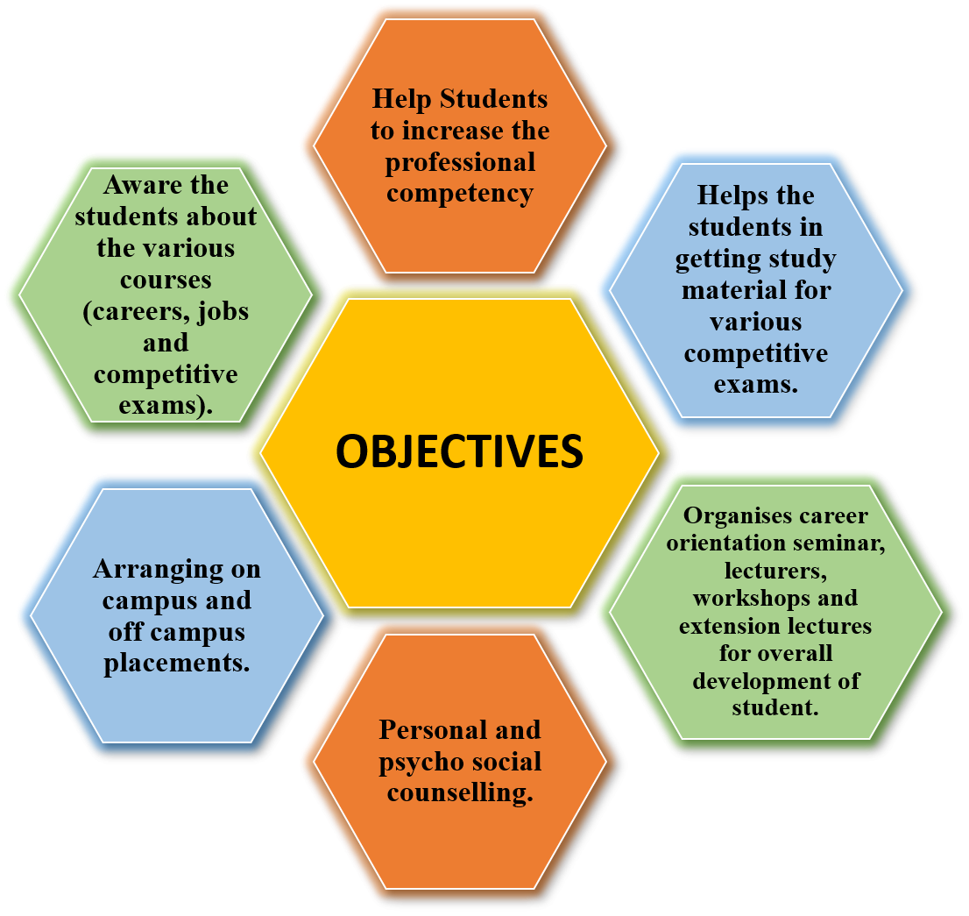
Detailed year wise list of events of Placement Cell

2016-17

Sr. No. | Name of Program | Date | No. of Students | Name of Agencies/Consultant
1 | Extension Lecture on 'Statistics and Career Prospectus' | 22-09-2016 | 120 | Prof. S.K. Malik, Deptt. of Statistics, Maharshi Dayanand University, Rohtak
2 | Extension Lecture on 'Career Opportunities for B.Sc. Medical Students’ | 14-10-2016 | 110 | Dr. Shalini, Assistant Professor, Deptt of Zoology, BMU Rohtak
3 | Extension Lecture on 'CBCS System and its role in Enhancing Employability’ | 24-10-2016 | 150 | Prof. Gulshan Taneja, Deptt. of Mathematics, Maharshi Dayanand University, Rohtak
4 | Extension Lecture on 'Exploring Online/ Web Resources for increasing Employability’ | 24-02-2017 | 130 | Dr. Pooja Mittal, Assistant Professor, Deptt. of Computer Science, Maharshi Dayanand University, Rohtak
5 | Placement-cum Training Program | 29-08-2016 to 01-09-2016 | 179 | Organized at Pt. NRS GC Rohtak (25 Students were shortlisted)

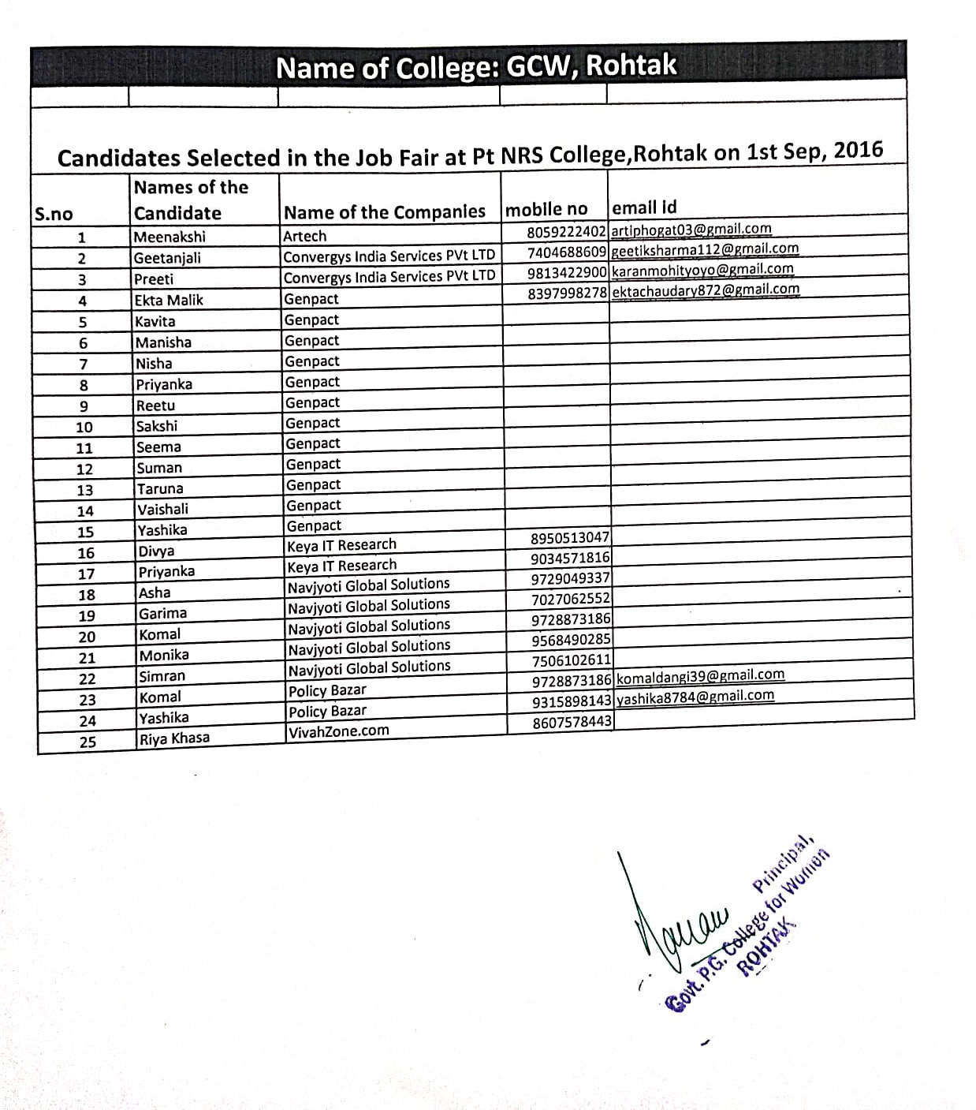

Placement-cum training Program, 29-08-2016 to 01-09-2016, Organized at Pt. NRS GC Rohtak (25 Students were shortlisted)

2017-18

Sr. No. | Name of Program | Date | No. of Students | Name of Agencies/Consultant
1 | A lecture on 'Opportunity of Placement' | 20-09-2017 |  | NIIT Rohtak
2 | Placement Drive | 25-09-2017 | 3 | Organized by Panipat Institute of Engineering and Technology Panipat
3 | One day Workshop on 'Career Avenues after Graduation' | 14-10-2017 |  | T.I.M.E. Pvt Ltd.
4 | Two Extension lectures on ‘Career Opportunities' | 30-01-2018 |  | T.I.M.E. Pvt Ltd.
5 | Women's only Campus Job Fair | 12-11-2017 | 2 | YES Centre Rohtak
6 | Three days Workshops on Soft-Skill' | 23-01-2018 - 25-01-2018 | 84 | Crown Institution of Education
7 | A Workshop on 'How to crack exam for Government Jobs' | 03-12-2018 | 120 | Career Height Institute Rohtak
8 | Placement Fair | 04-12-2018 | 9 | Pt NRS GC Rohtak
9 | Placement-cum Training Program | 07-11-2017 - 10-11-2017 | 112 | Pt NRS GC Rohtak (27 Students were Shortlisted)
10 | Campus Placement | 22-03-2018 |  | Vaish College Rohtak (one Student was selected in WIPRO )
11 | Placement Fair | 04-12-2018 | 9 | Pt NRS GC Rohtak (03 Students were Selected)
12 | Haryana Skill Development Mission | 20-04-2018 |  | Health Care Administration (Anjali B.Sc. Non- Med was selected)

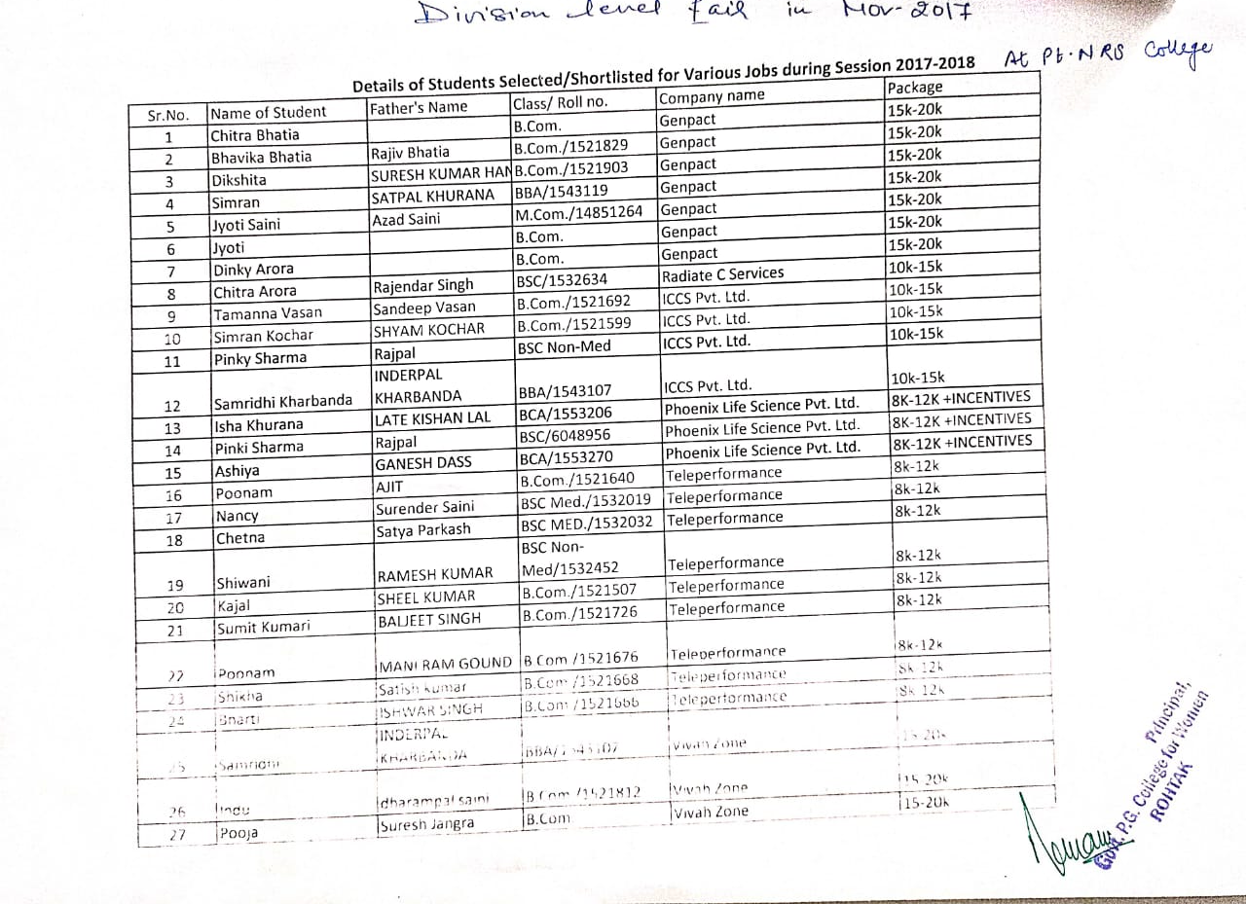

Placement-cum training Program, 07-11-2017 to 10-11-2017, Pt NRS GC Rohtak (27 Students were Shortlisted)

2018-19

Sr. No. | Name of Program | Date | No. of Students | Name of Agencies/Consultant
1 | Two Lectures on 'To explore life -Insurance sector opportunities' | 13-10-2018 | 100 | Kodak Life and Mr. L.N. chahan ,Branch manager Oriental Bank
2 | Two days workshop on 'Soft- Skill' | 22-01-2019 to 23-01-2019 | 113 | Triumphant Institute of Management Education Pvt ltd. Rohtak
3 | Mega Job Fair | 15-07-2019 | 27 | A.I.J.H.M College Rohtak
4 | Placement-cum training Program | 28-01-2019 to 31-01-2019 | 153 | Pt NRS GC Rohtak (36 Students were Shortlisted)
5 | Infosys Placement Drive | 02-06-2019 |  | GRD Roper Chandigarh (Sonia BCA was selected)

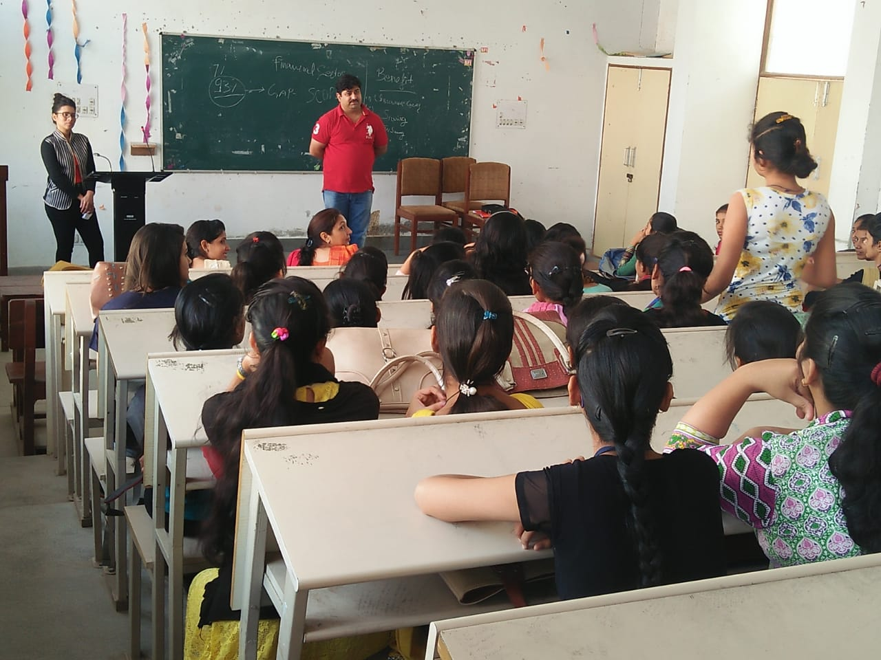 | 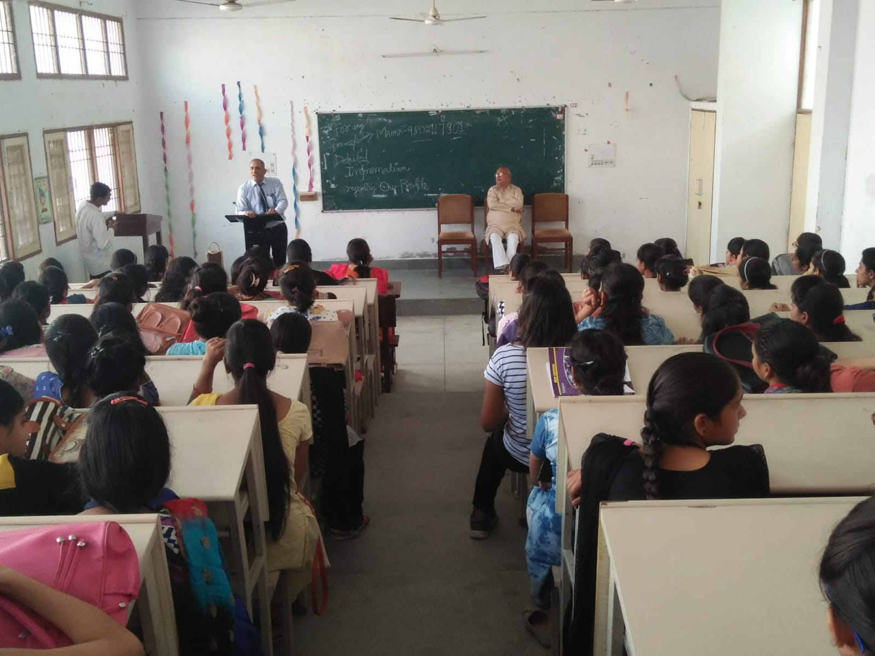

Two Lectures on 'To explore life -Insurance sector opportunities' on 13-10-2018

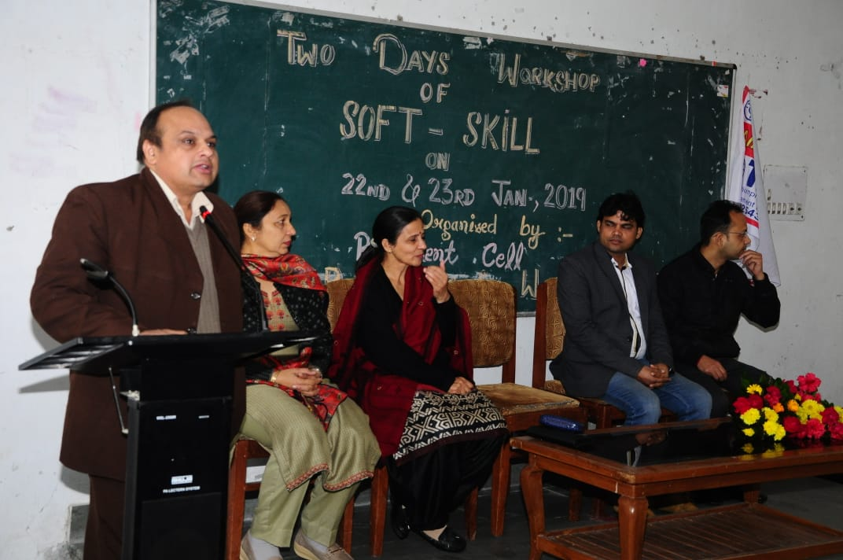

Two days’ workshop on 'Soft- Skill' 22-01-2019 to 23-01-2019

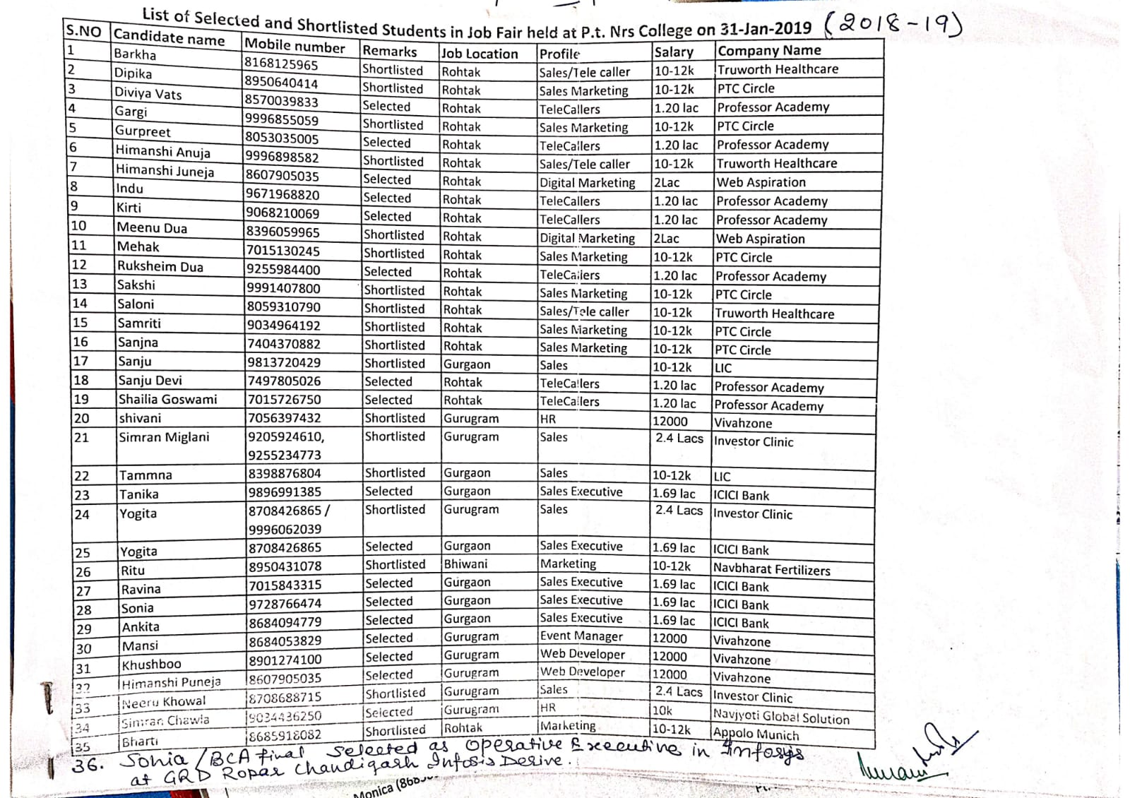

Placement-cum training Program, 28-01-2019 to 31-01-2019, Pt NRS GC Rohtak (36 Students were Shortlisted)

2019-20

Sr. No. | Name of Program | Date | No. of Students | Name of Agencies/Consultant
1 | Extension Lecture on 'Career Counselling' | 30-08-2019 | 90 | Dr S.S.Gill MDU Rohtak
2 | A Seminar on 'Soft-Skill' | 25-09-2019 | 105
3 | Extension Lecture on 'Campus to Corporate' | 10-10-2019 |  | Dr Divya
4 | Three days’ workshop on ' Soft-Skill' | 16-01-2020 to 18-01-2020 | 108 | Career Launcher Institute Rohtak
5 | Placement-cum Training Program | 21-01-2020 to 24-01-2020 | 110 | Pt NRS GC Rohtak (58 Students were Shortlisted)
6 | Infosys Mega Placement Fair | 02-07-2020 | 5 | GRD Roper Chandigarh
7 | TCS Drive | 30-11-2020 | 5 | TCS at Bhagwan Parshuram Institute Delhi (One student was selected)

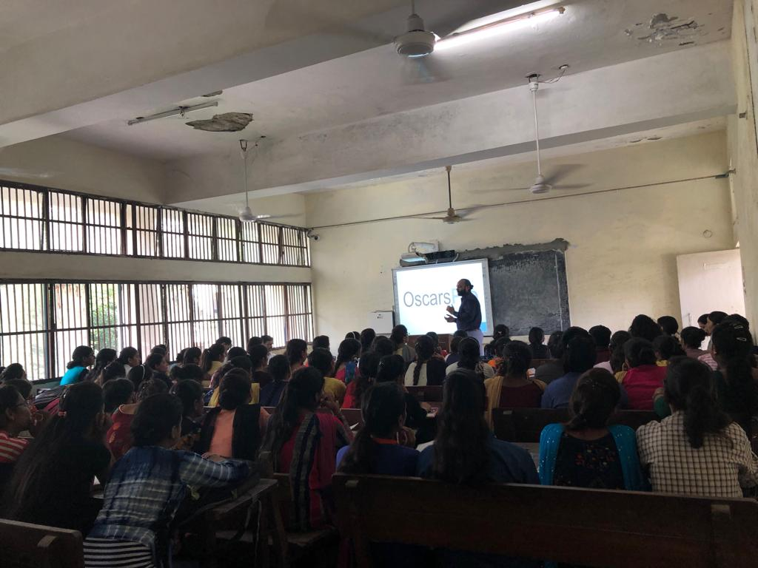

Extension Lecture on 'Career Counselling' on 30-08-2019

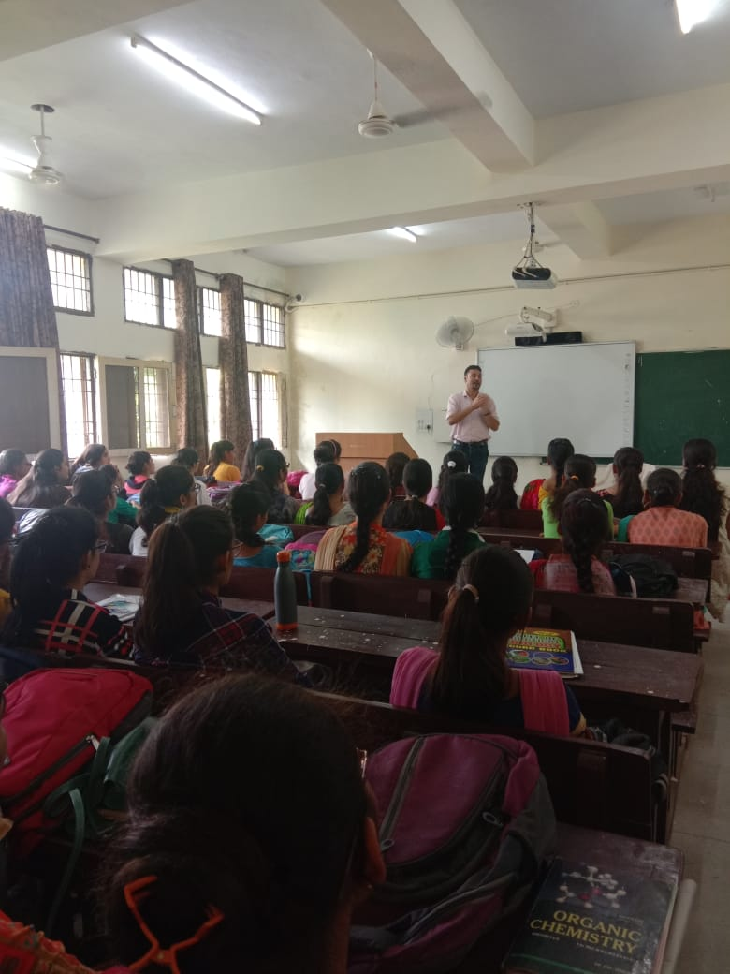

Seminar on 'Soft-Skill' on 25-09-2019

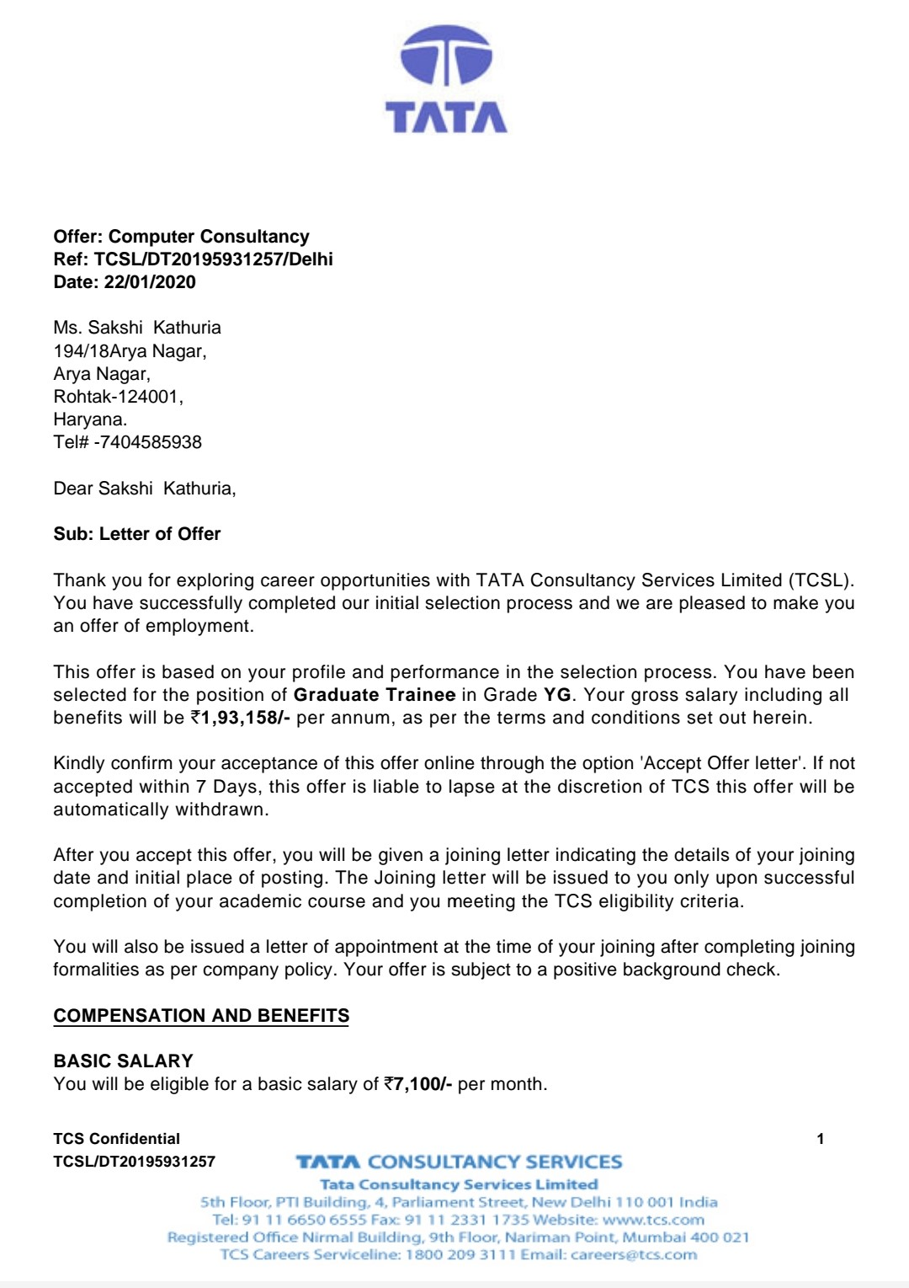 | 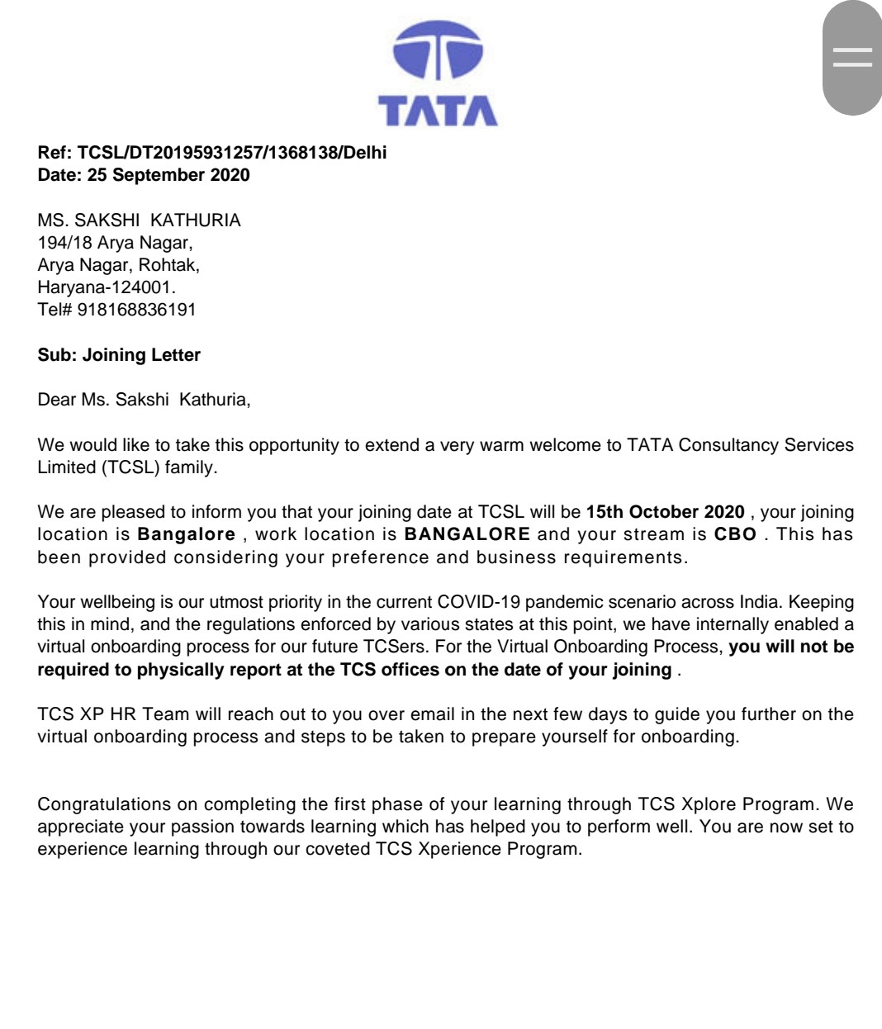

Offer letter and joining letter of student Sakshi in TCS
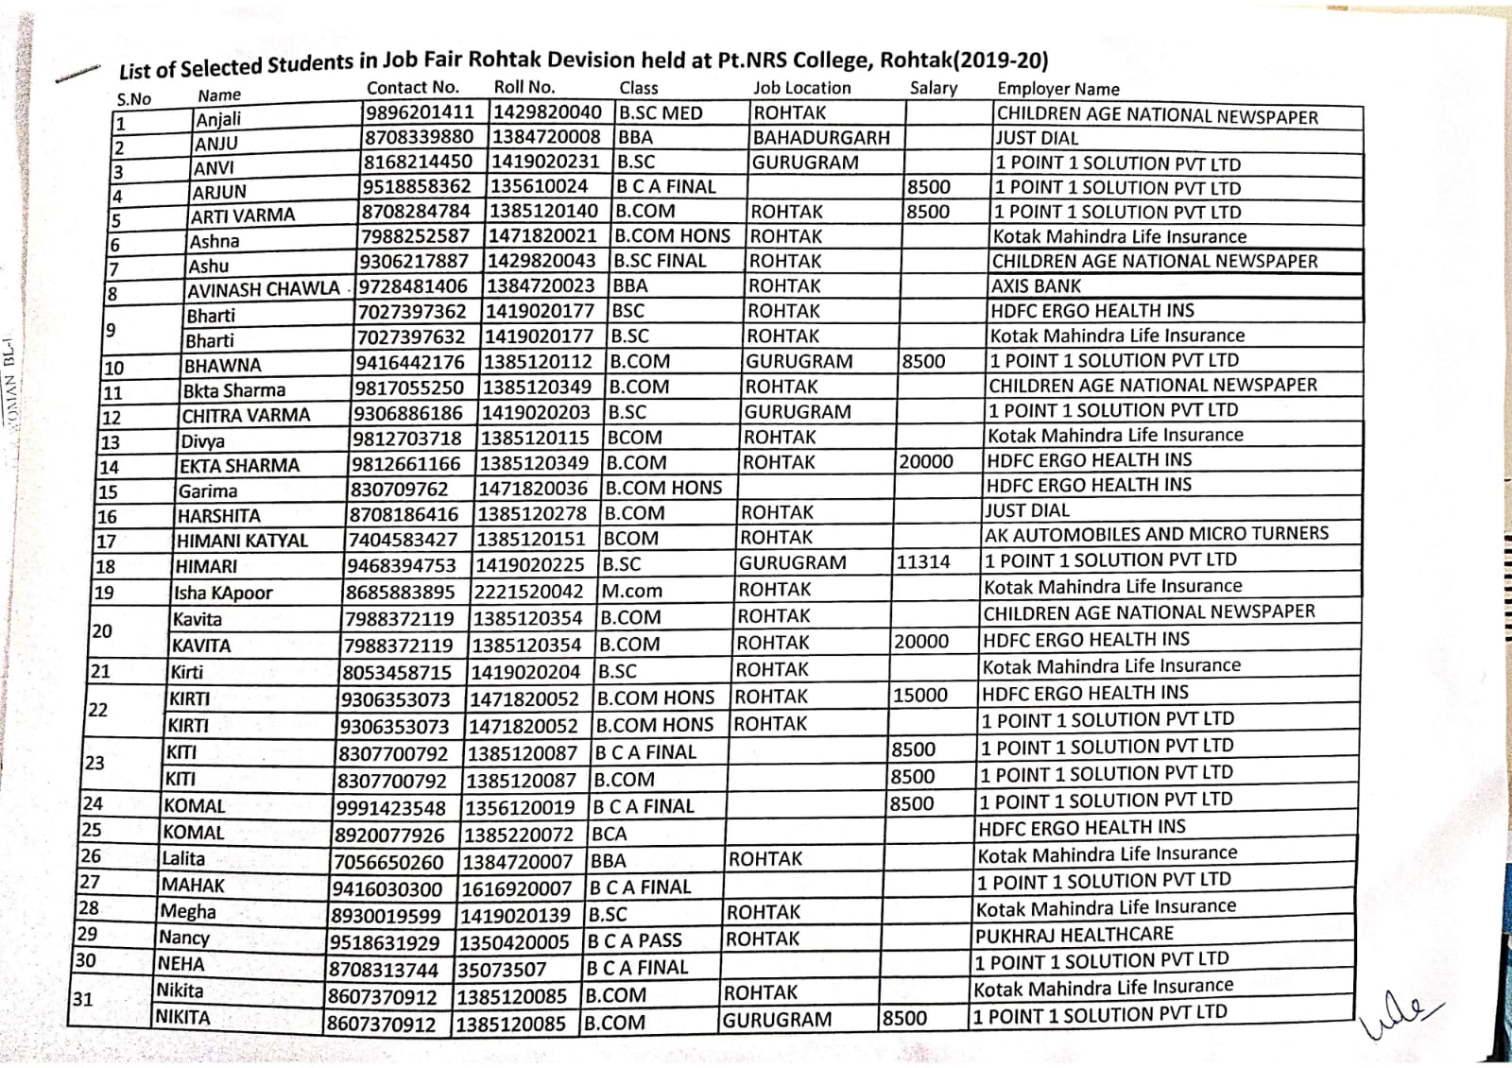
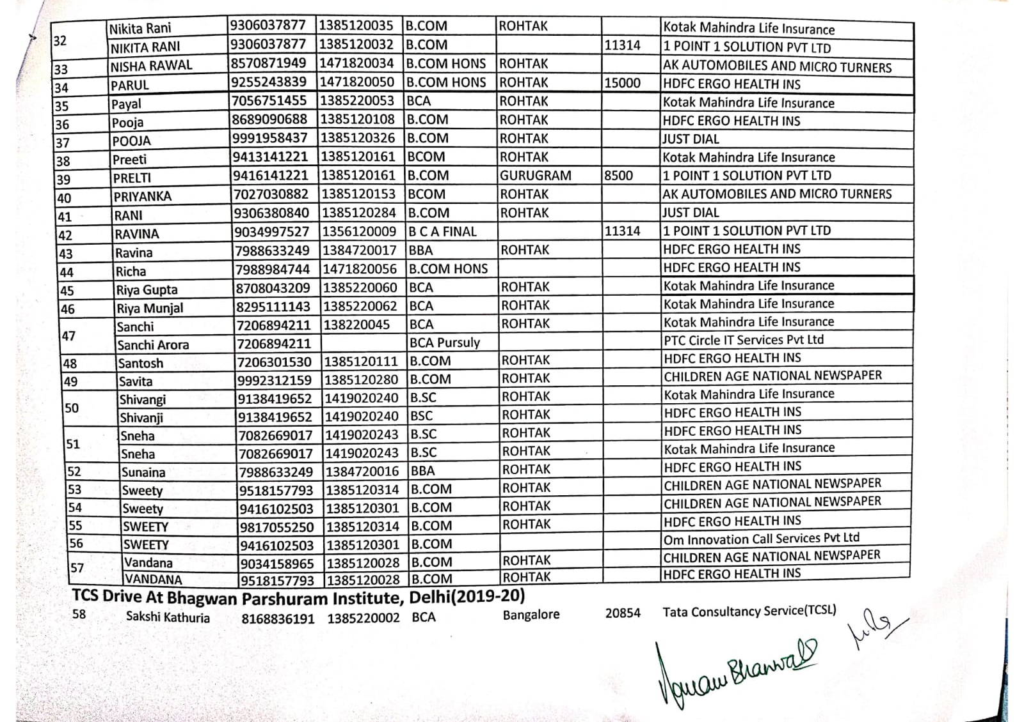
Shortlisted students, Placement-cum Training Program on 21-01-2020 to 24-01-2020, at Pt NRS GC Rohtak. ( 58 students were shortlisted)

2020-21

Sr. No. | Name of Program | Date | No. of Students | Name of Agencies/Consultant
1 | Webinar on "How to job ready for post covid-19 opportunities" | 01-07-2020 |  | GVMITM
2 | Infosys Placement Drive | 14-12-2020 | 48 | GRD Roper Chandigarh
3 | Online Infosys Placement Drive at MDU | Feb., 2021 | 4 | GRD Roper Chandigarh
4 | One day Workshop on 'Soft Skill and Resume Writing' | 11-11-2021 | 290 | Career Launcher

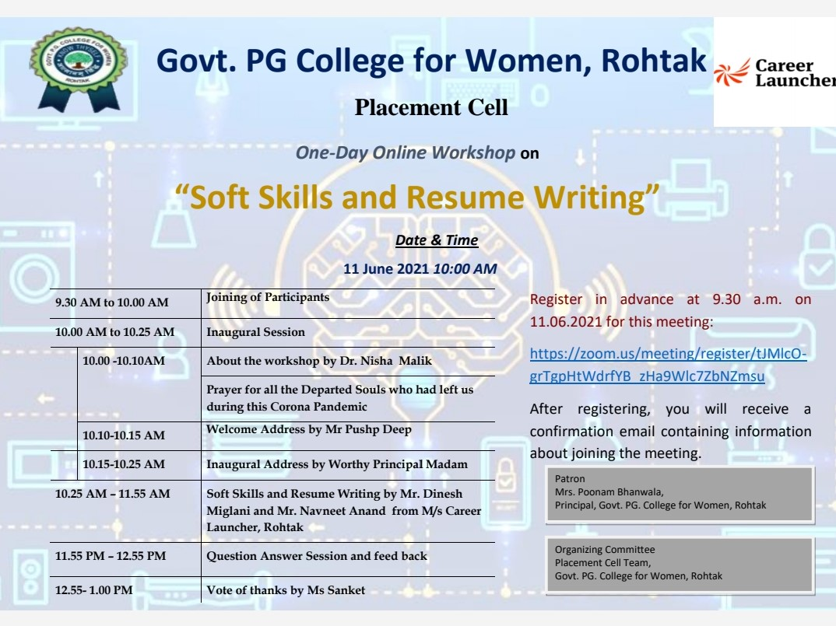 | 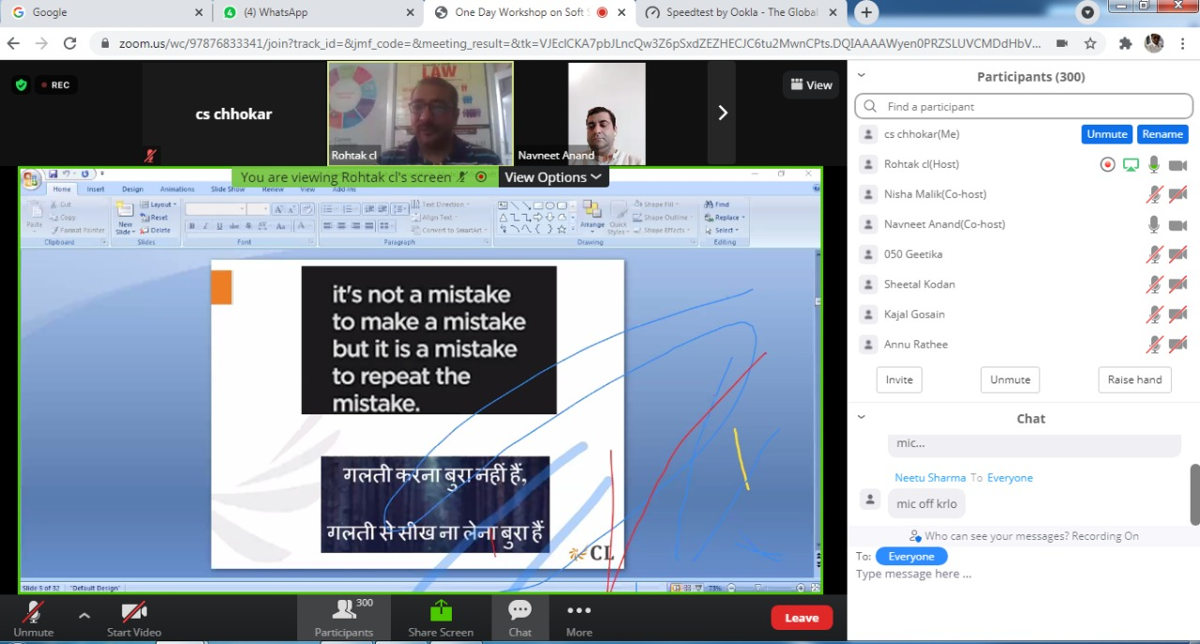
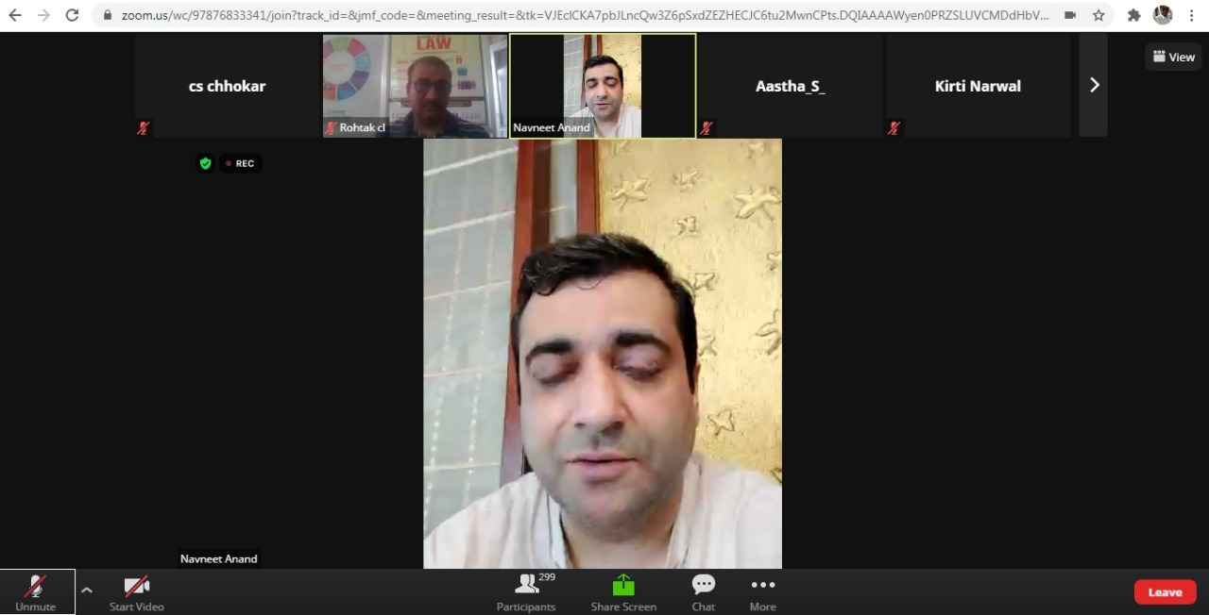 | 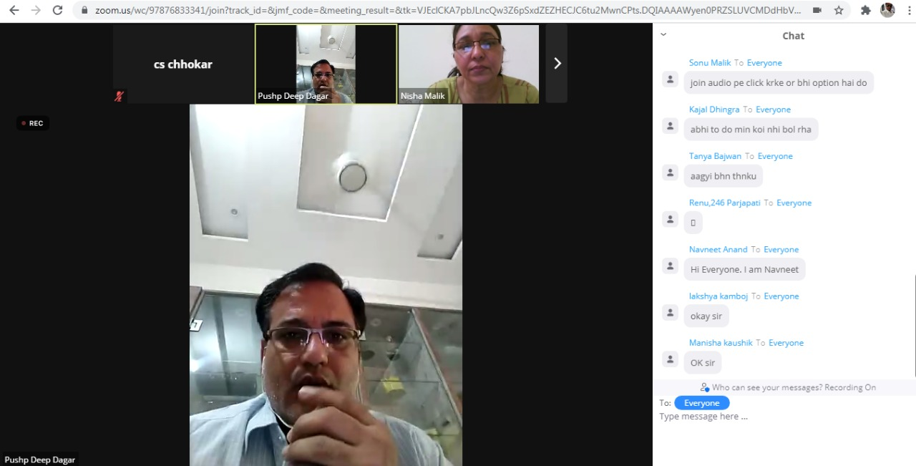
One day Workshop on 'Soft Skill and Resume Writing' on 11-11-2021

