**PLACEMENT CELL REPORT (2021-22)**

Placement Cell serves as a platform for stakeholders to meet out the aspiration of the young girl students. The Cell plays a key role in locating the job-oriented career opportunities for the final year undergraduate and postgraduate students by encouraging them to participate in several Placement-cum-Training Programmes. The cell organises regular aptitude/ technical training programmes to improve their soft skills. Moreover, it also conducts extension lectures for providing them the tips regarding time management, professional resume and CV writing etc.

Furthermore, the placement cell holds various extension lectures by eminent resource person from different institutes like MDU, Rohtak, Baba Mastnath University, Rohtak, NIIT, Rohtak and TIMES Groups etc. Through a series of workshops and personality building assignments, the placement cell strives to transform an average student to an extraordinary employee with excellent work ethics. The cell buckles down on remaining transparent, technologically driven and dynamic throughout the year. Besides conducting placement drives for the benefit of the student, the placement cell is also committed to honing their skills in the best possible manner.

Our team consists of the following members

1. Dr. Nisha Malik (convener)

2. Dr. Puspdeep Dagar (member)

3. Dr. Satyawan Jatain (member)

4. Mrs. Savita Malik (member)

5. Mrs. Nirmala Soni (member)

6. Dr. Bhupender singh (member)

7. Mr. Chain Singh (member)

8. Mr. Jogender Singh (member)

9. Ms. Sonika (member)

10. Mrs. Sanket (member)

**Vision**

Equipping the students with relevant and conceptualized professional skills

and to guide them for embarking on a successful career journey.

**Mission**

* To groom the students and make them aware of current scenarios of various
* industries.
* To ensure 100% placement assistance.
* To maintain good liaison with the recruiters.
* To inculcate the quality of taking on industry challenges and emerging out as
* young leaders.
* To develop strong analytical and competitive skills.

**Placement cell organized various activities for the welfare of the students during the whole year.**

|  |  |  |  |  |
| --- | --- | --- | --- | --- |
| **Sr. No.** | **Name of Program** | **Date** | **No. of Students** | **Name of Agencies/Consultant** |
| 1 | Online interviews | 22-09-2021 | 28 | JK Technofest |
| 2 | Online Placement events | 03-10-2021 | 12 | GRD Group of Colleges, Ropar  (One student Bharti Sharma was selected) |
| 3 | Divisional level Job fair | 09-02-2022 | 190 | Pt. NRS Govt. College, Rohtak (47 students were selected) |
| 4 | Lecture on ‘Availability of courses and its importance in employability of plastic industry’ | 19-04-2022 | 76 | Mrs. Nisha, CIPET, Murthal |
| 5 | Placement drive in GPGCW, Rohtak | 28-04-2022 | 131 | Bharti Associates, Rohtak Branch (46 students were shortlisted) |
| 6 | Lecture on ‘How to prepare for UPSC’ | 26-05-2022 | 183 | Mr. Shashank Jha, Mr. Nikhil Meharwal and Mr. Vikas Bhardwaj |
| 7 | Skill Development Agreement for 3 years | 26-06-2022 | - | Saylor Academy |

**Activity1:**

In sep.2021, as per the mail of the Technofest received on 22-09-2021 they conducted online interview of 28 students as per the resume shared between 24-09-2021 to 29-09-2021.

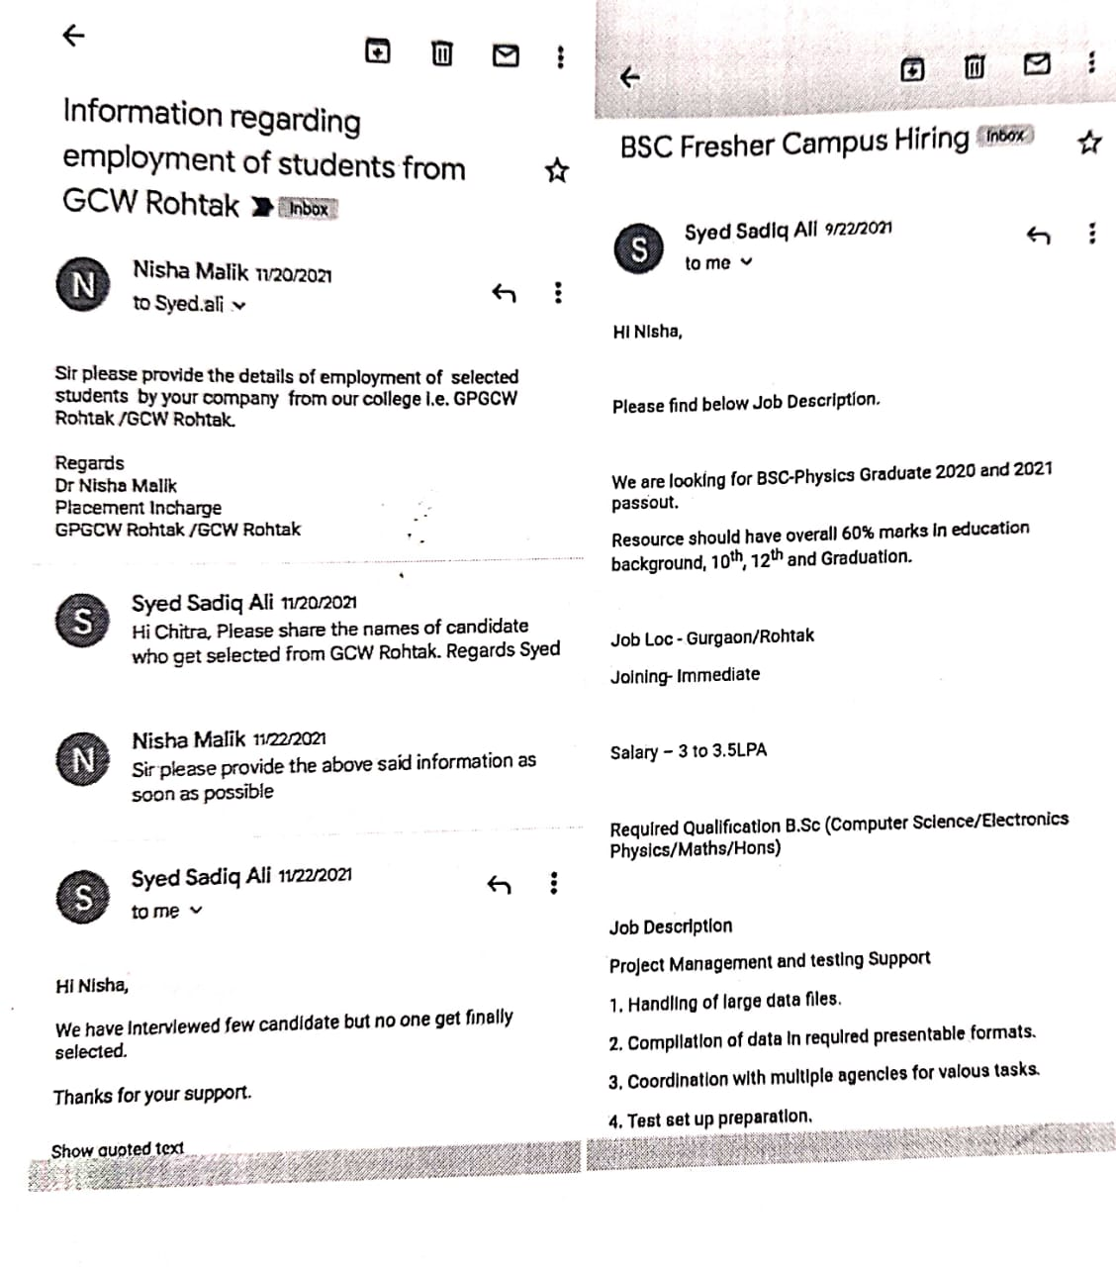

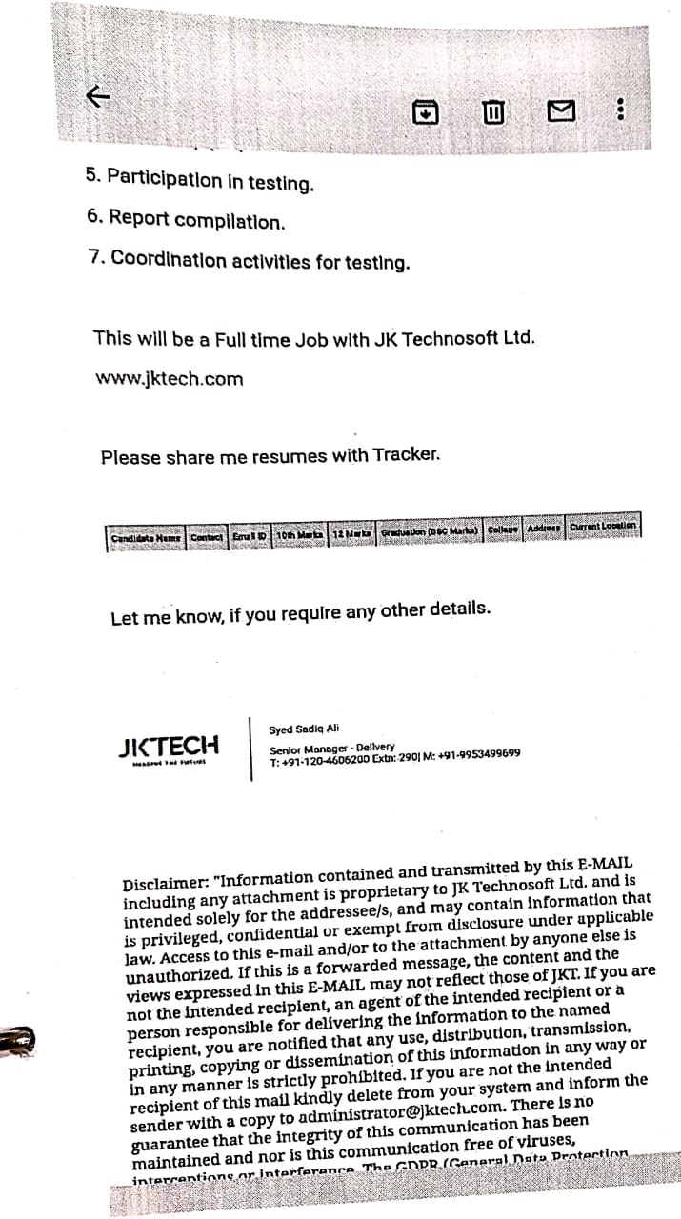

**Activity 2:**

12 students of BCA/BSc participated in online placement event dated on 03-10-2021 organized by GRD Group of colleges, Ropar. One student of BSc final year(computer science) Bharti Sharma was selected.

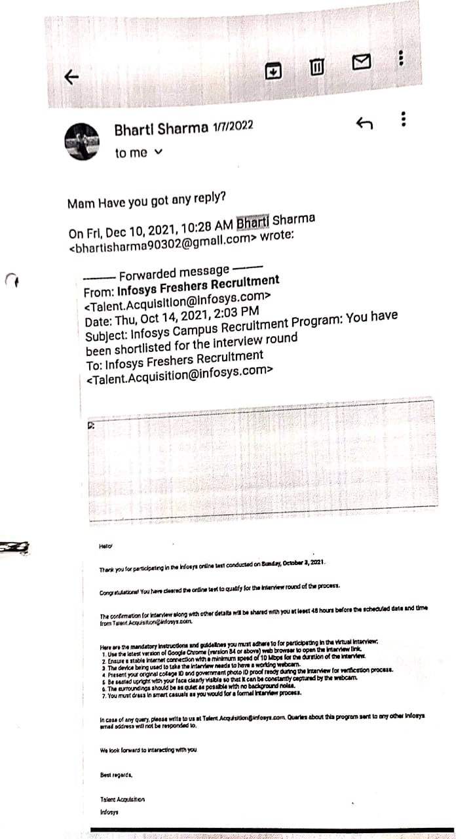

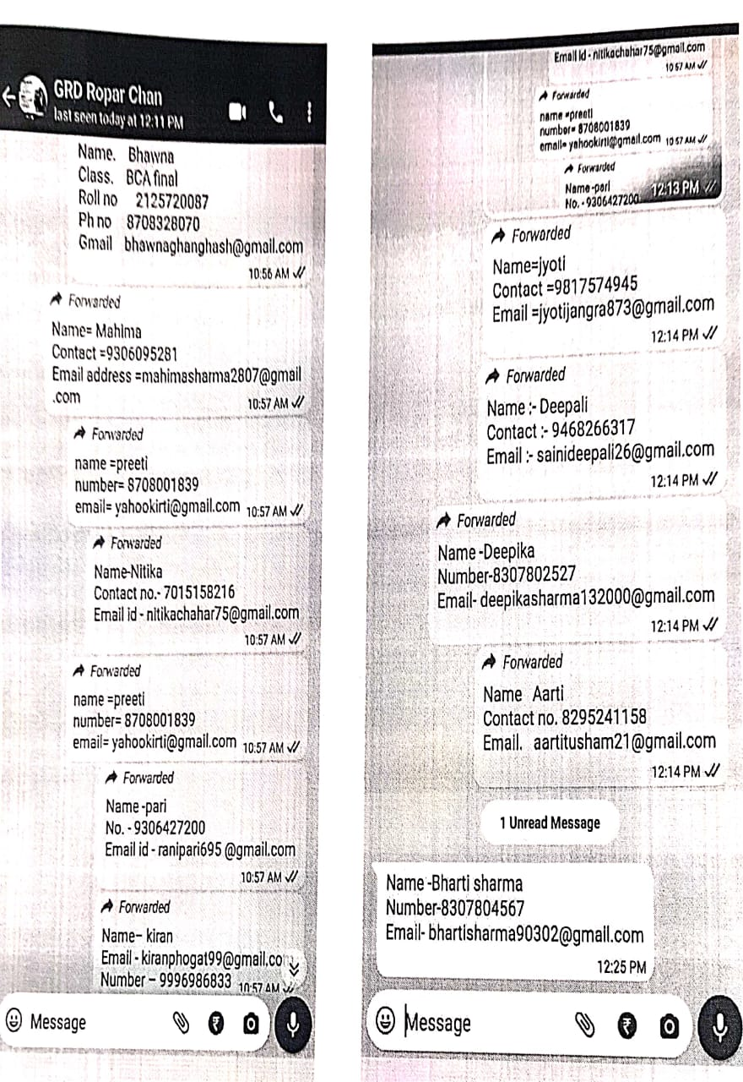

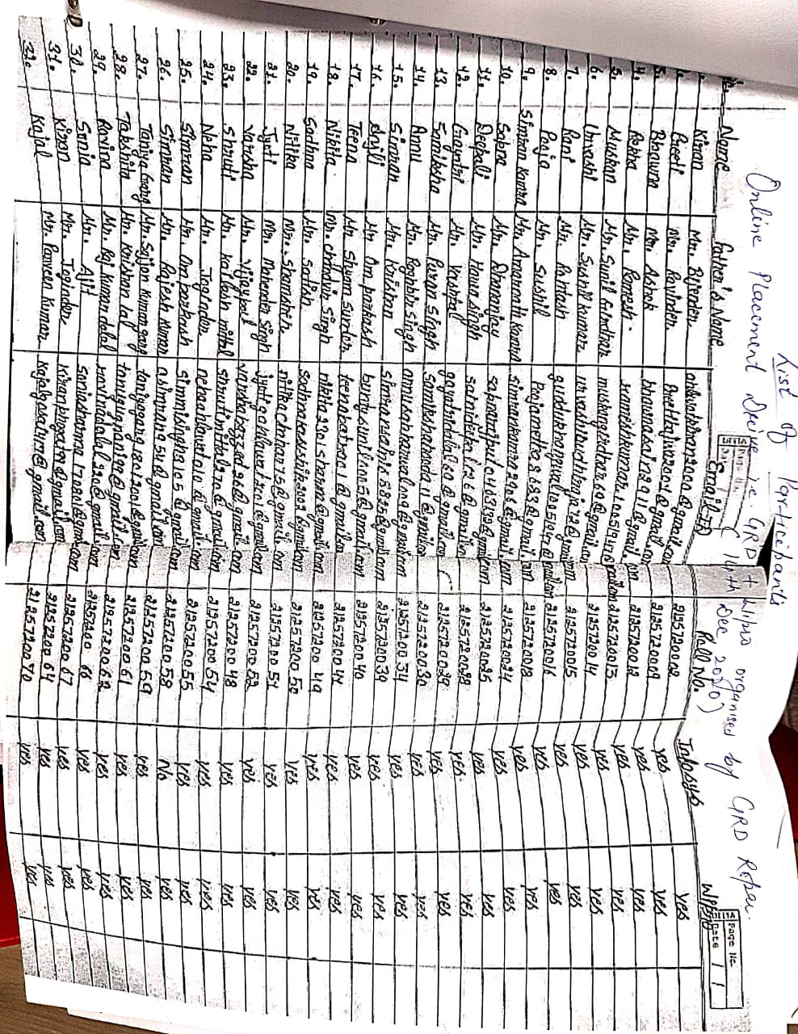

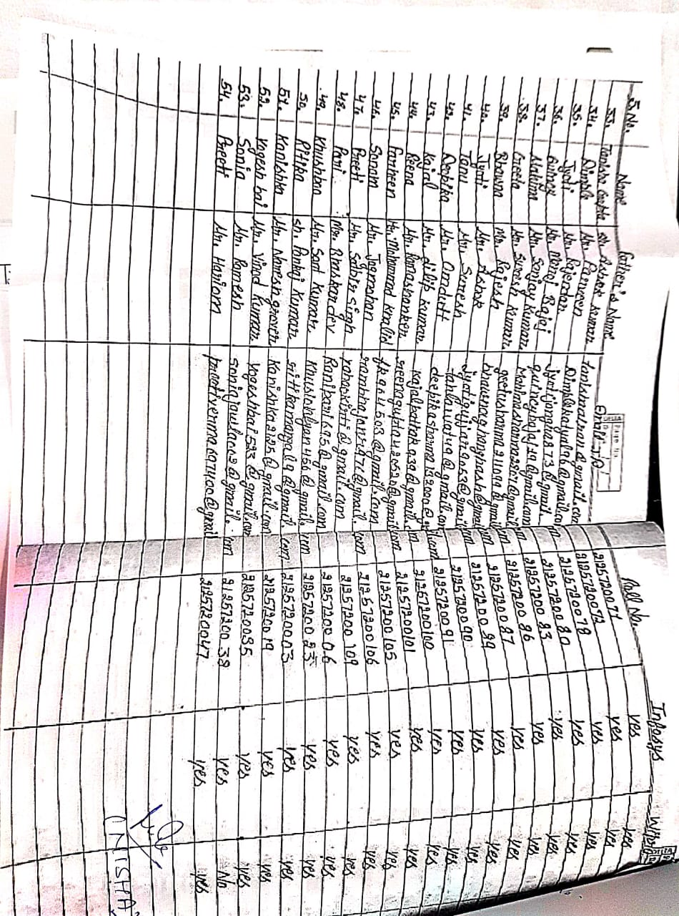

**Activity 3:**

On 9th feb.2022 190 students of UG/PG(final year) participated in Divisional level job fair held at Pt. NRS Govt.college Rohtak. Out of which 37 students got offer letter from various organizations participated in this event.

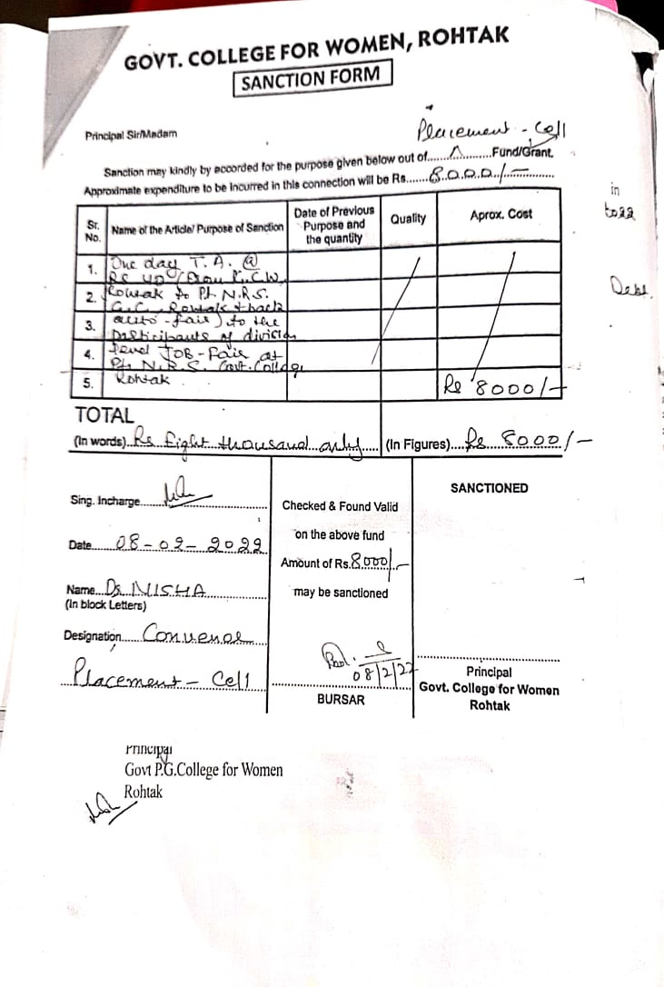

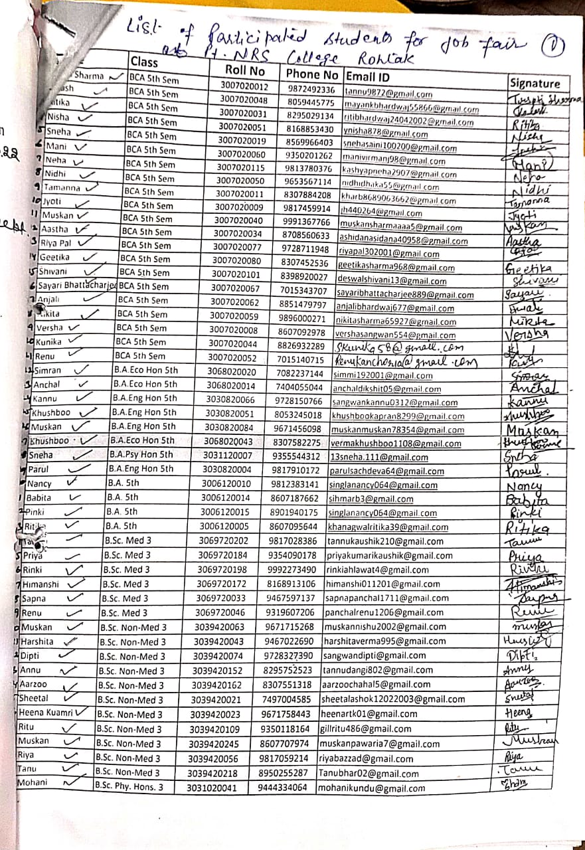

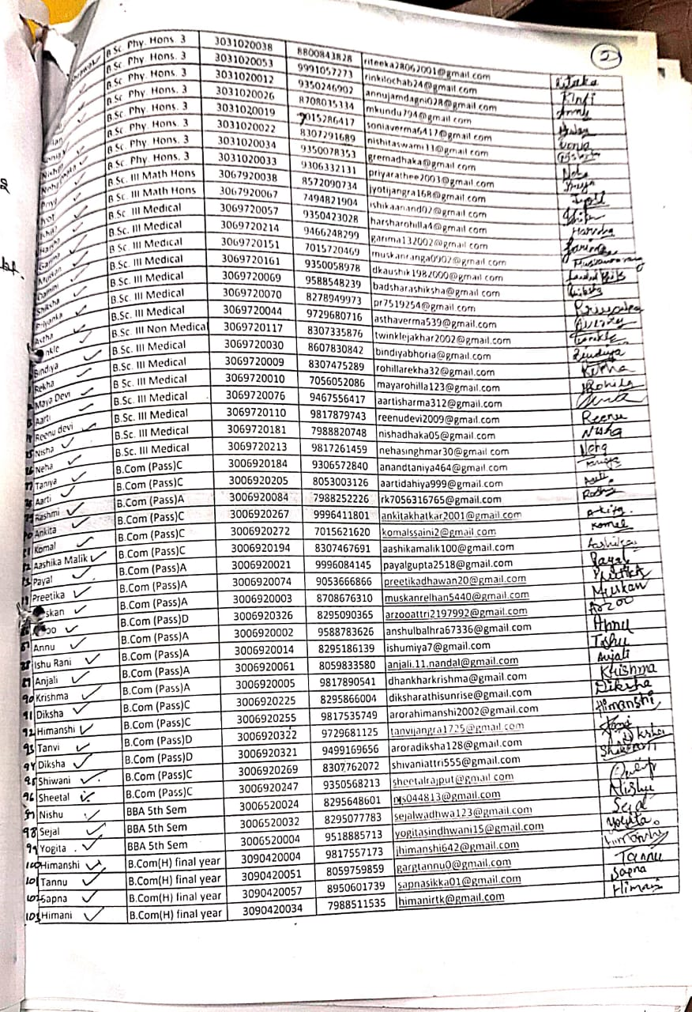

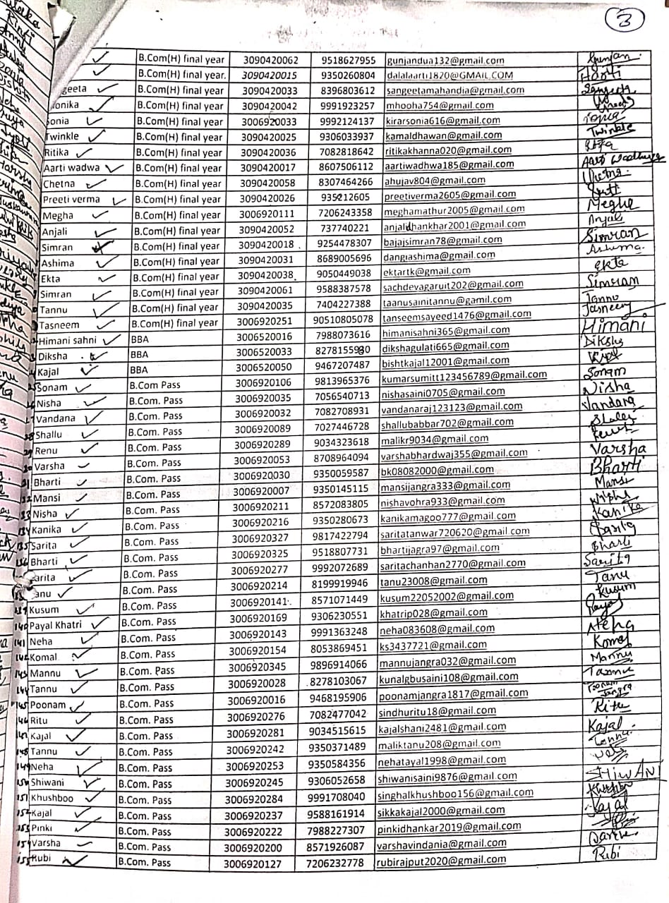

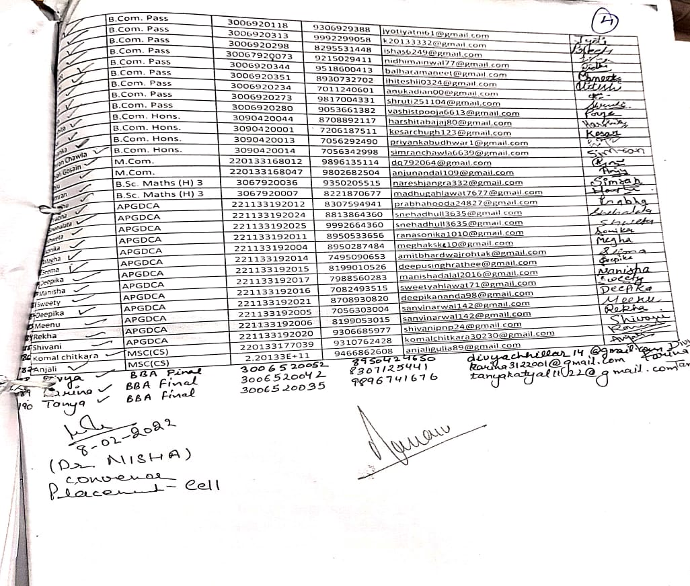

**Activity 4**:

On 19th April 2022 a lecture was delivered by Mrs. Nisha from CIPET, Murthal and explained the availability of courses and its importance in the Employability of Plastic Industry. Total 76 students from BSc(final year) get benefitted. In this lecture Mrs. Nisha elaborated admission process and gave the course outline.

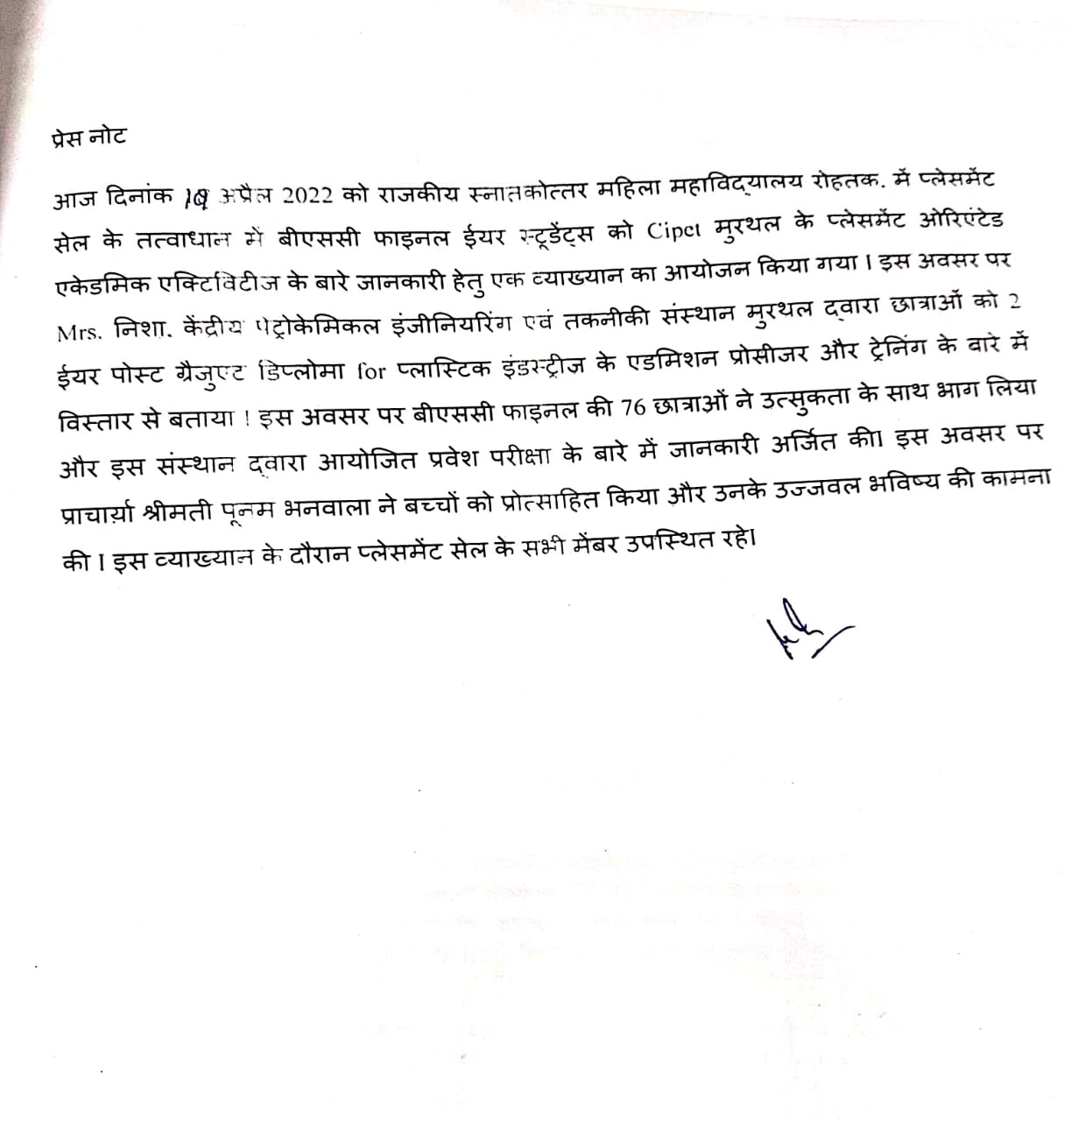

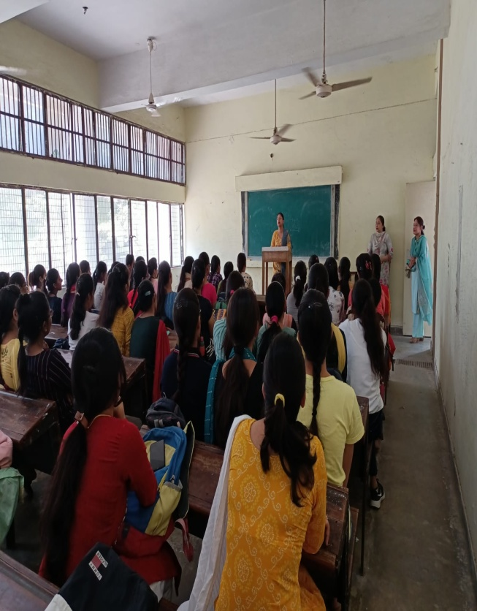 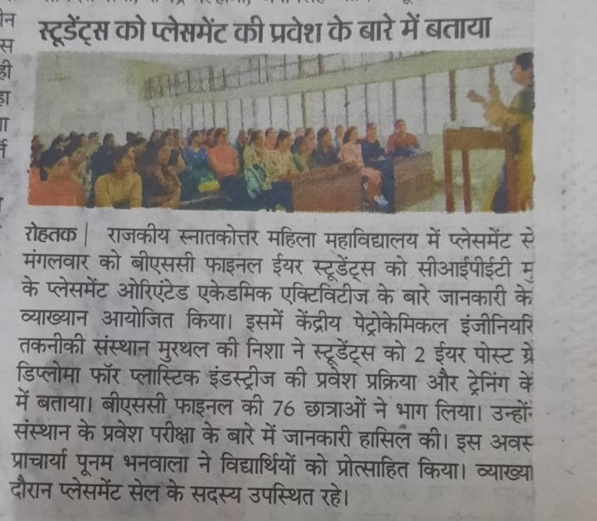

**Lecture on ‘Availability of courses and its importance in employability of plastic industry’ on 19-04-2022 by Mrs. Nisha, CIPET, Murthal**

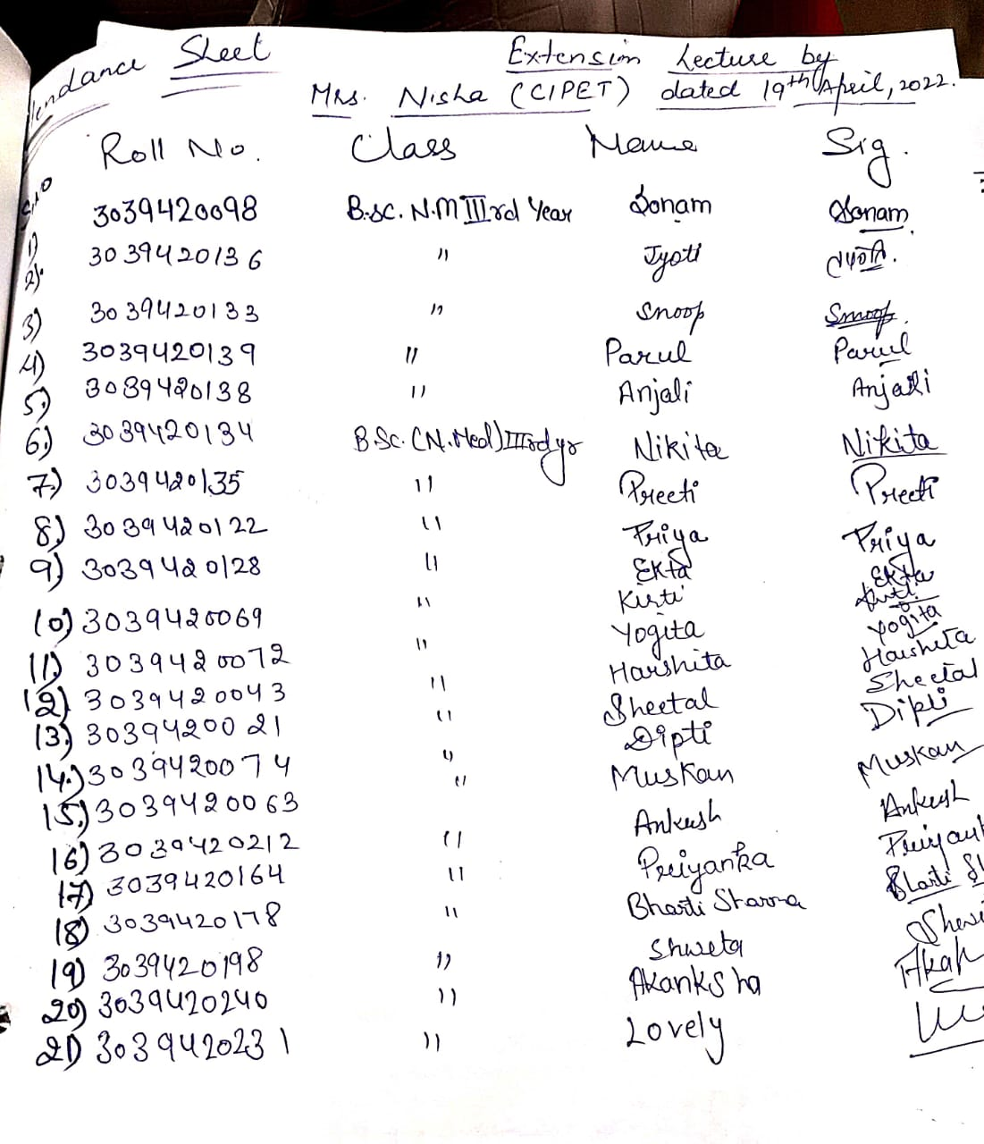

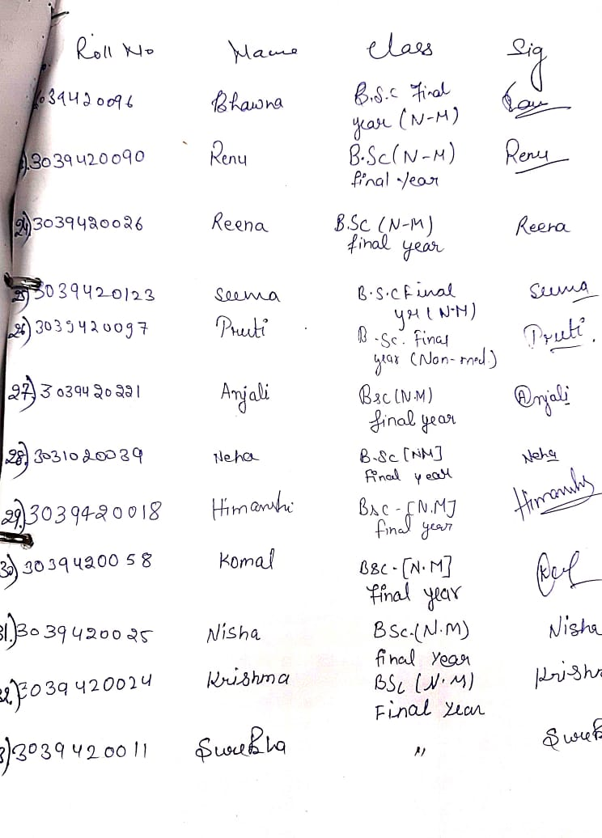

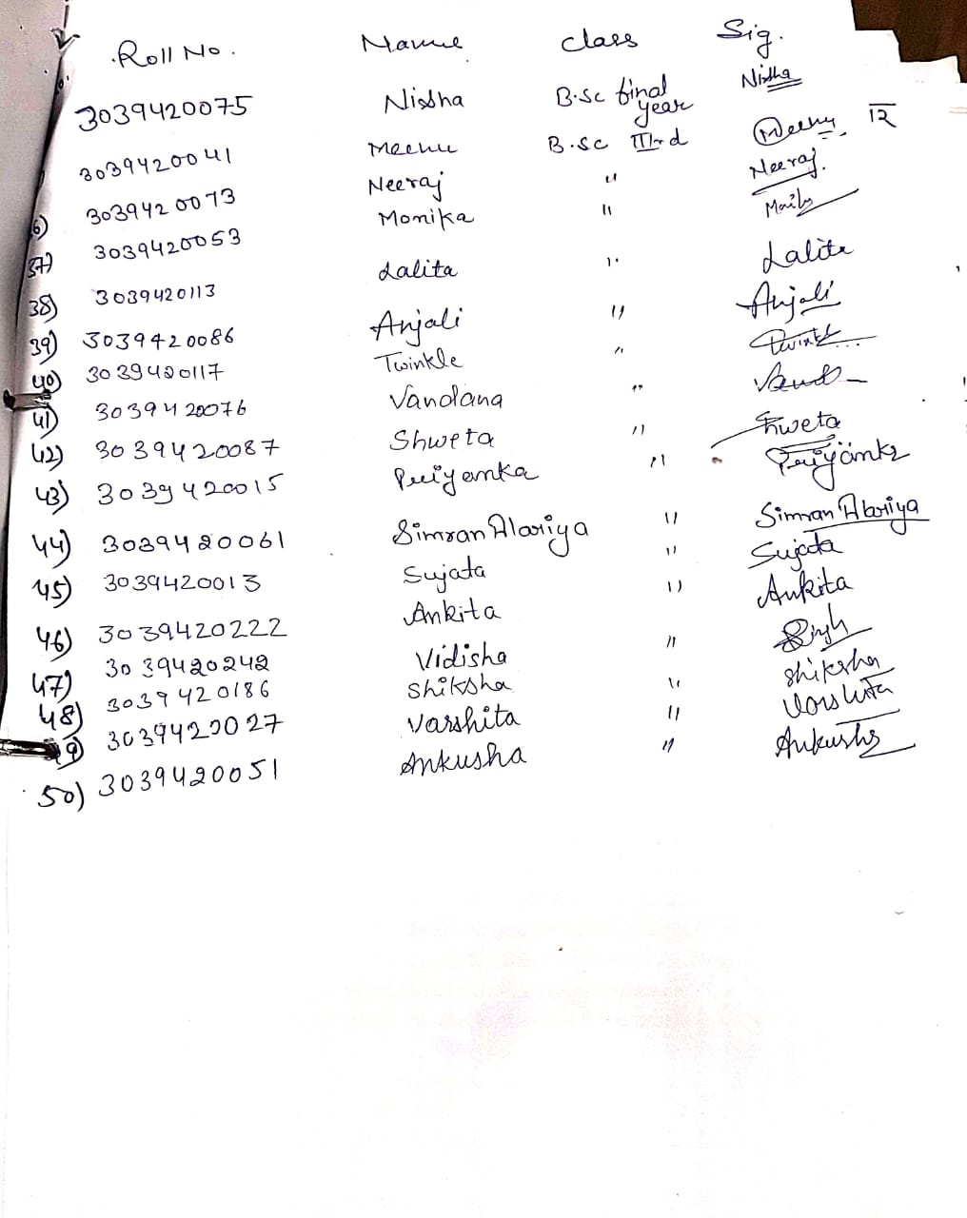

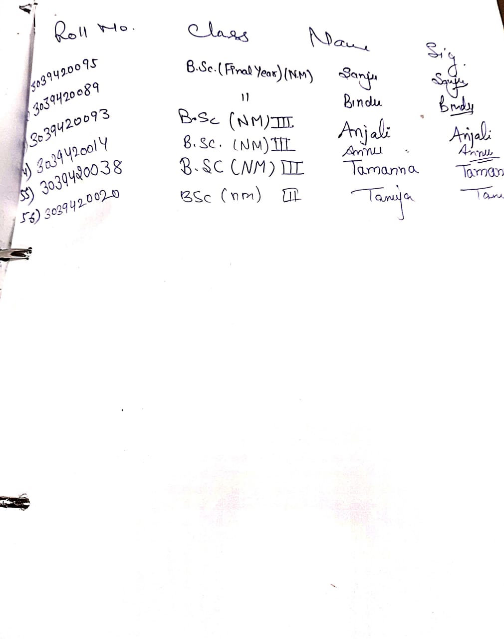

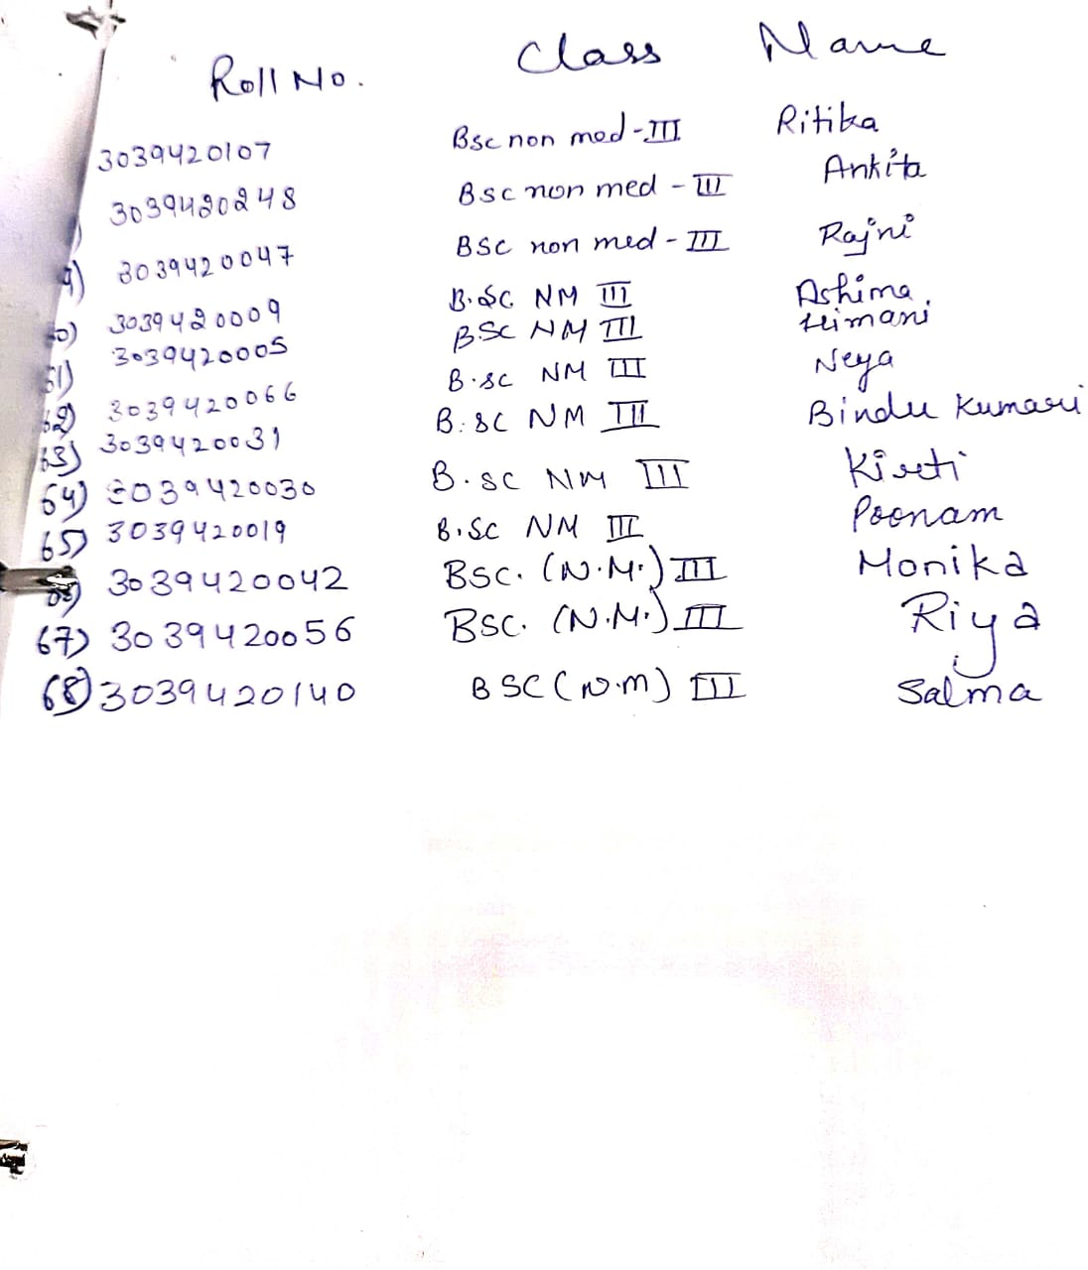

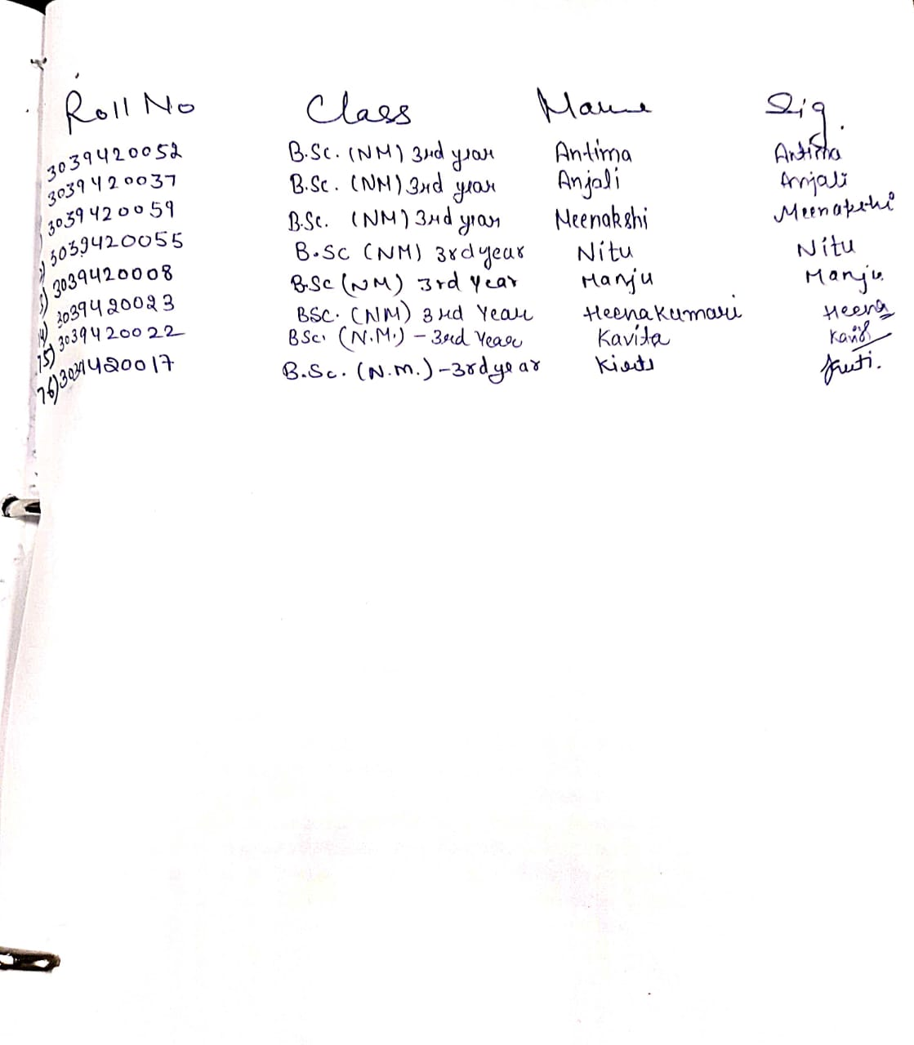

**Activity 5:**

On 28th April 2022 Bharti Associates, Rohtak branch conducted a placement drive at our campus for final year students of UG/PG. Total 131 students participated in this event. The placement activity was conducted in two phases. In first phase 64 students were shortlisted and in next phase personal interview was conducted for all these selected students and 47 students were shortlisted for next phase of interview to be conducted at their branch office.

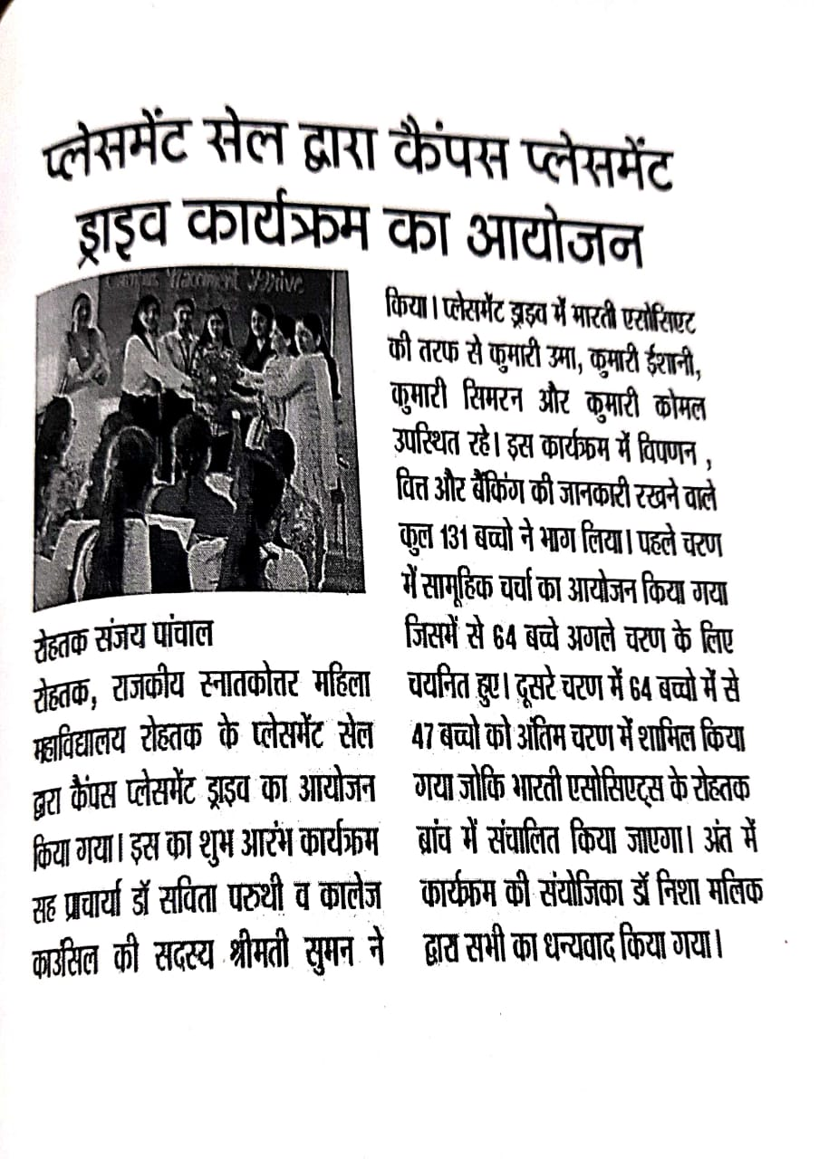

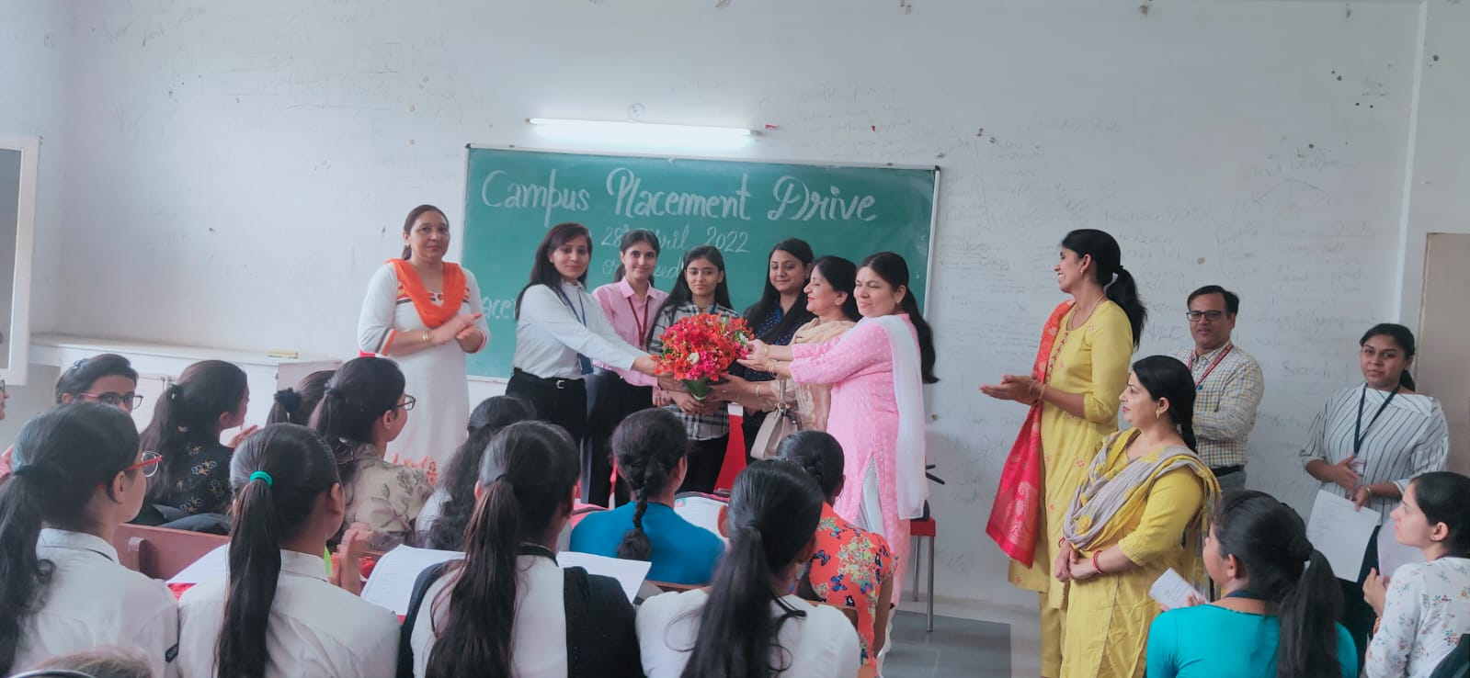

**Placement drive in GPGCW, Rohtak, 28-04-2022, Bharti Associates, Rohtak Branch (46 students were shortlisted)**

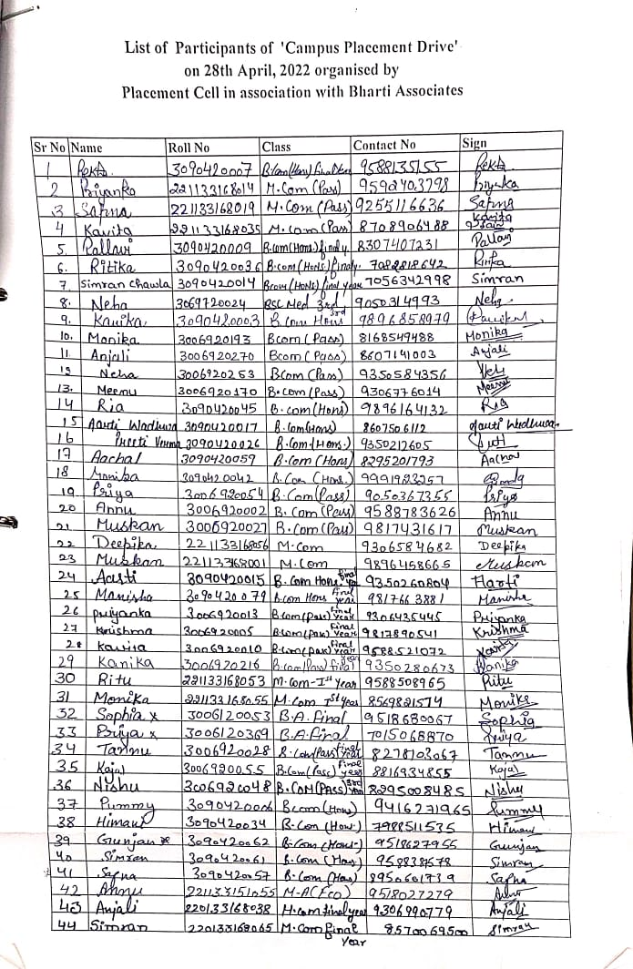

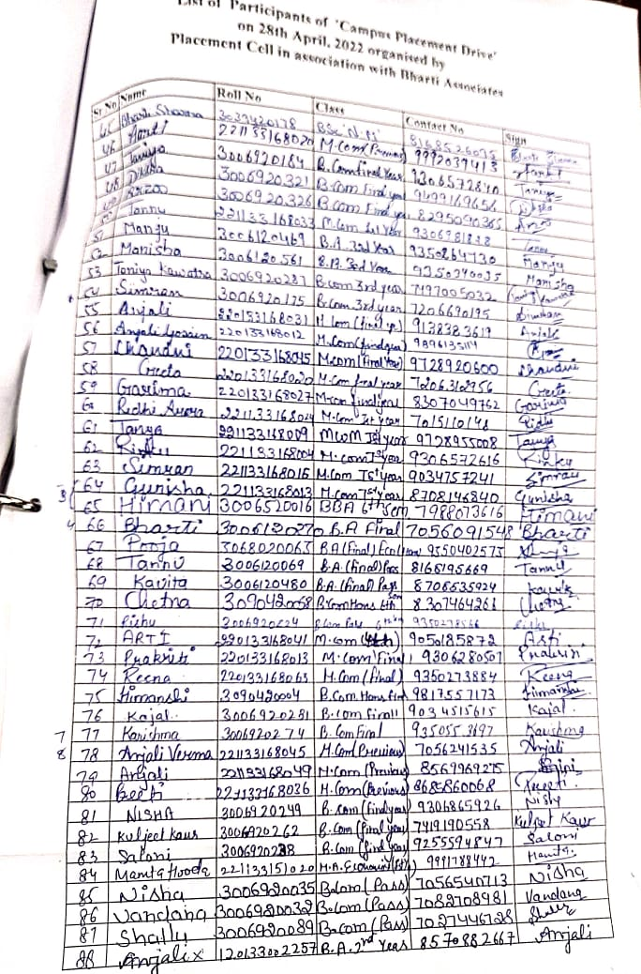

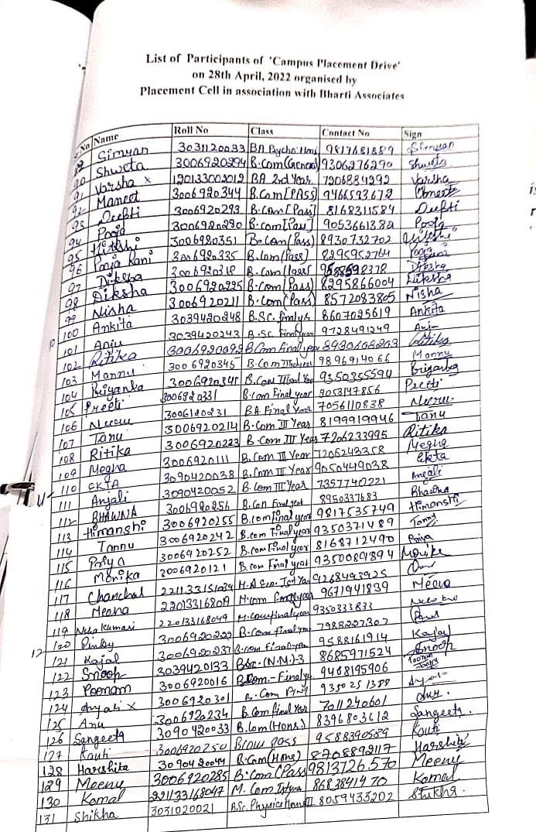

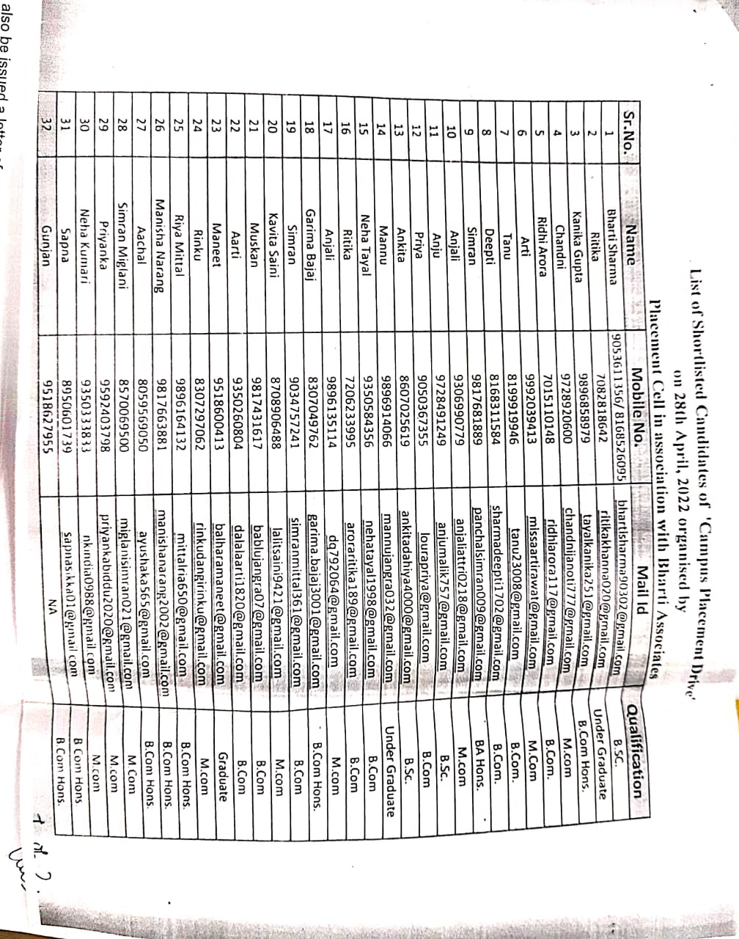

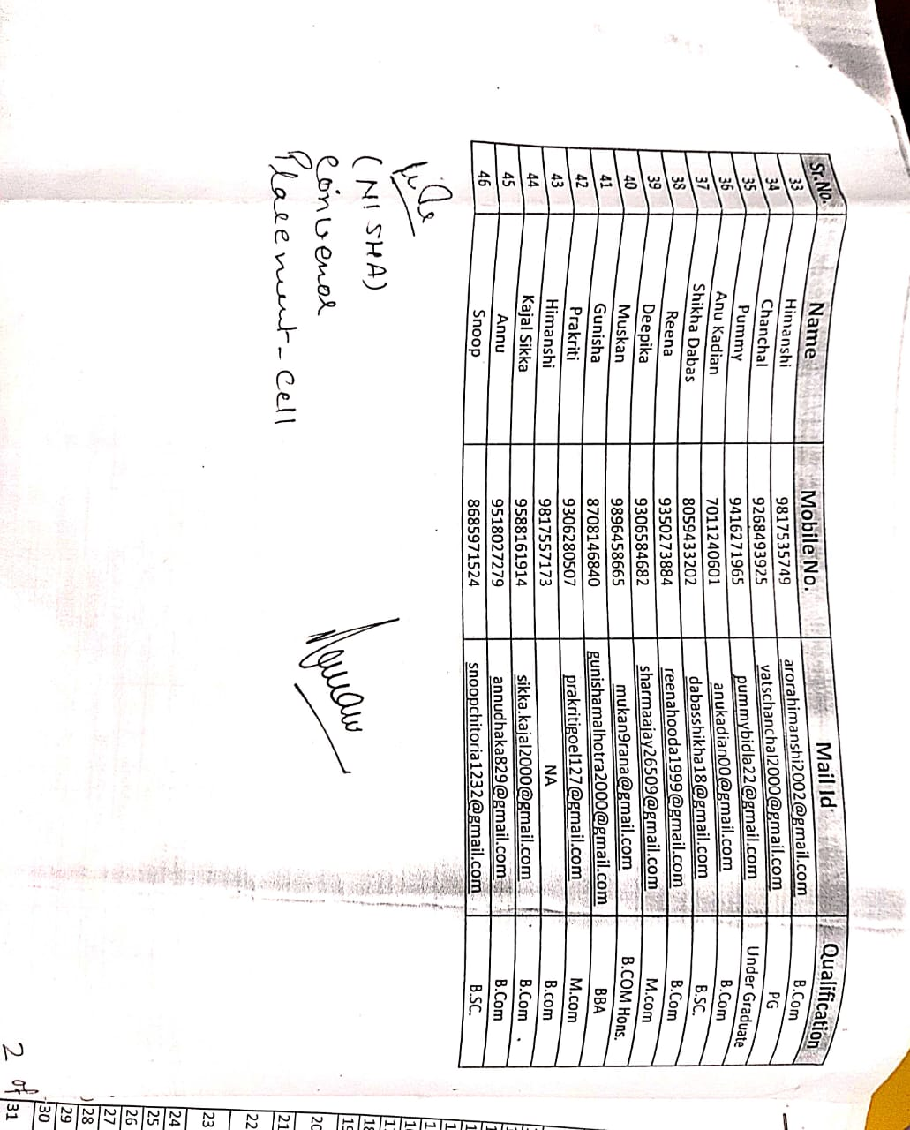

**Activity 6:**

On 26th May 2022, a lecture was organized by Shashank Jha, Nikhil Meharwal and Vi kas Bhardwaj on “How to prepare for UPSC.” Total 183 students were participated and get benefit by this lecture.

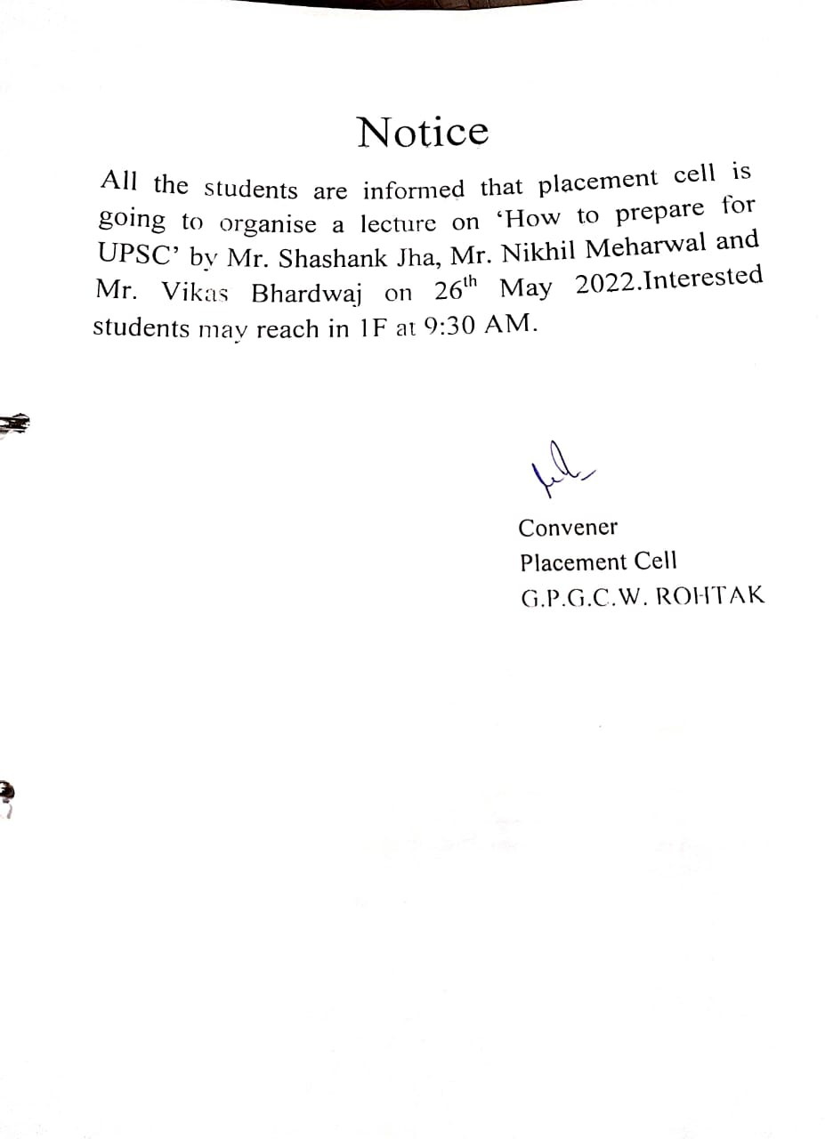

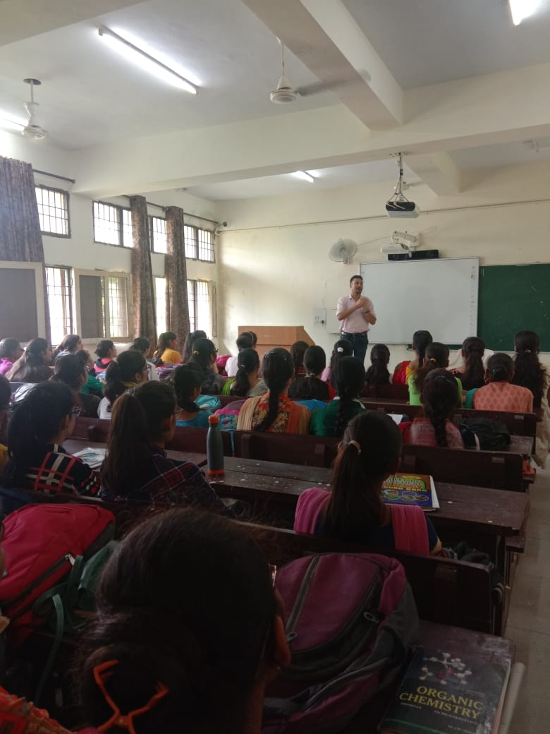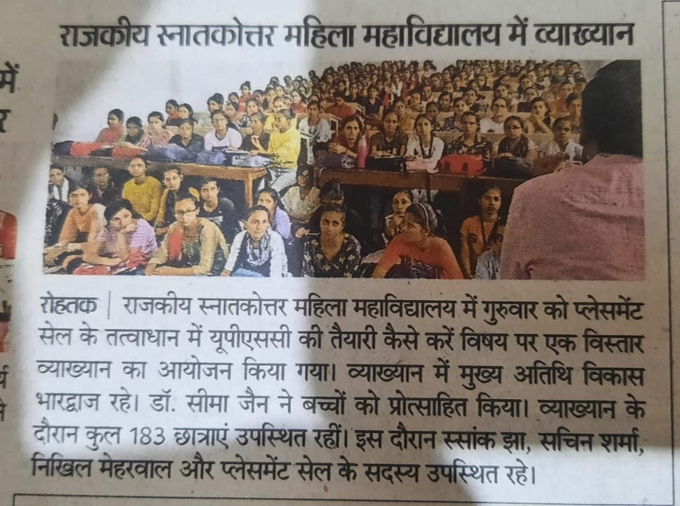

**Lecture on ‘How to prepare for UPSC’ on 26-05-2022 by Mr. Shashank Jha, Mr. Nikhil Meharwal and Mr. Vikas Bhardwaj**

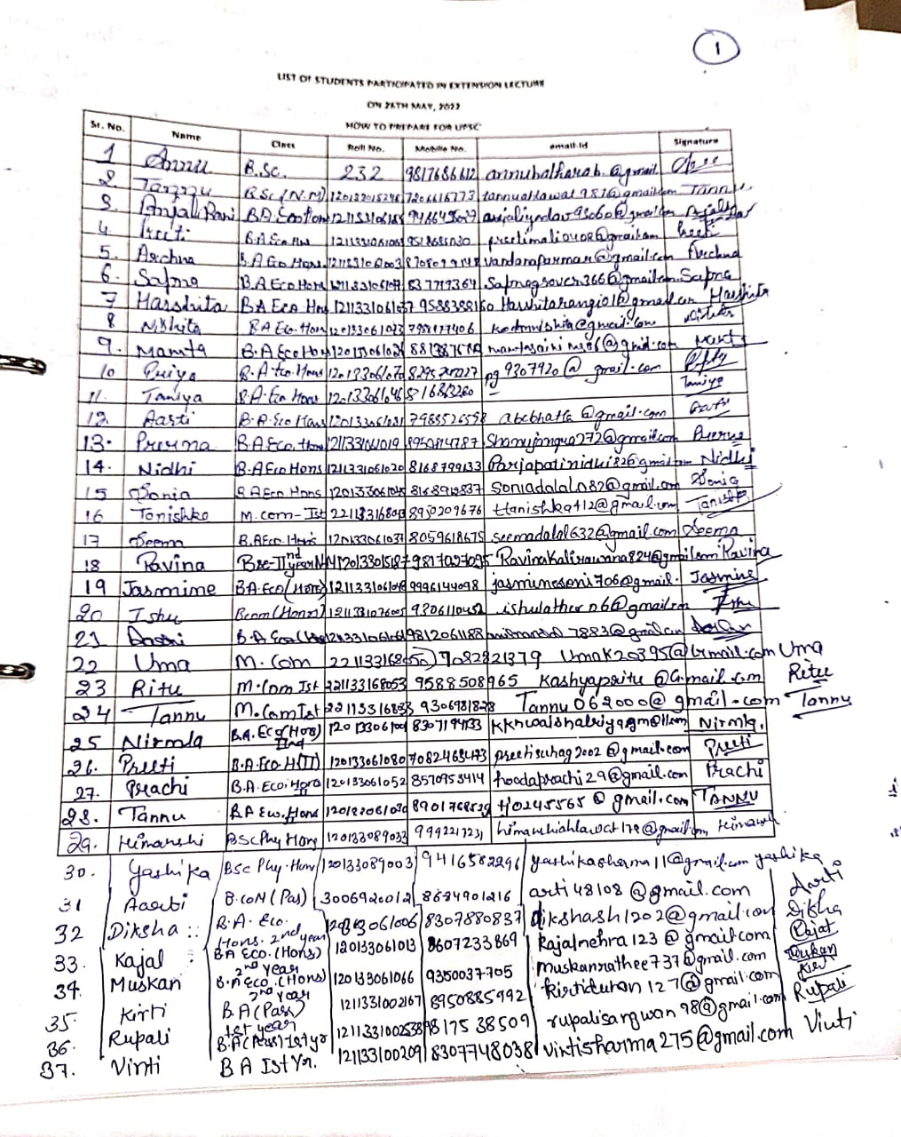

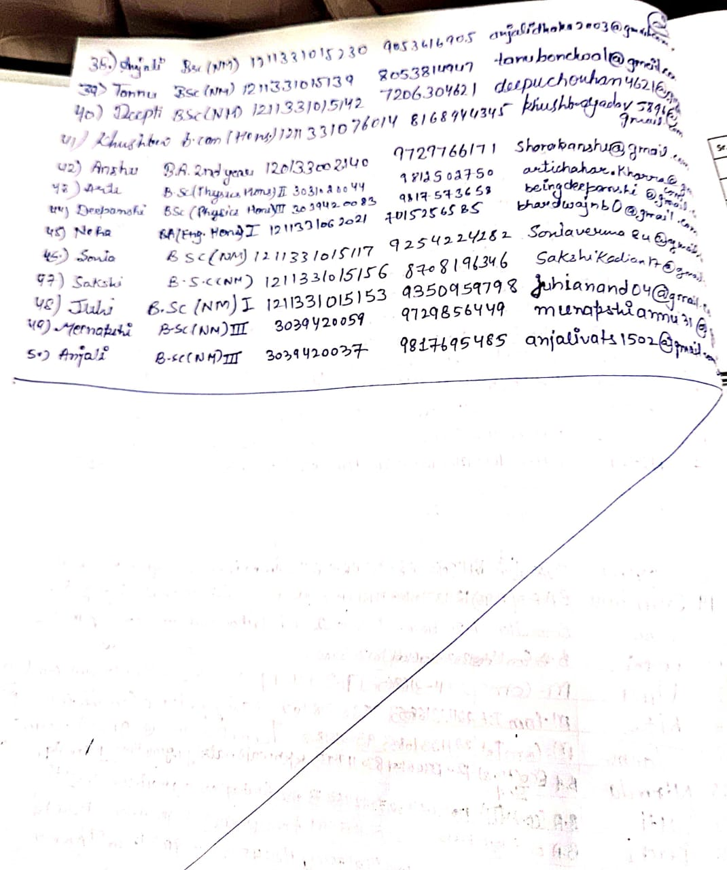

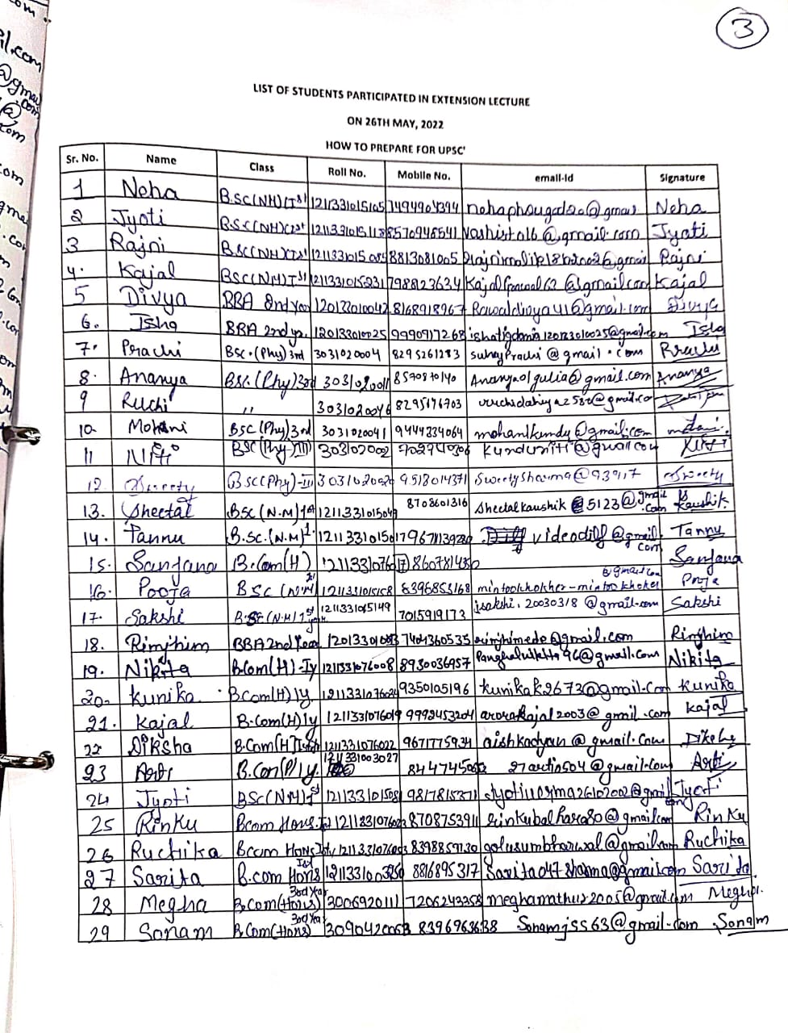

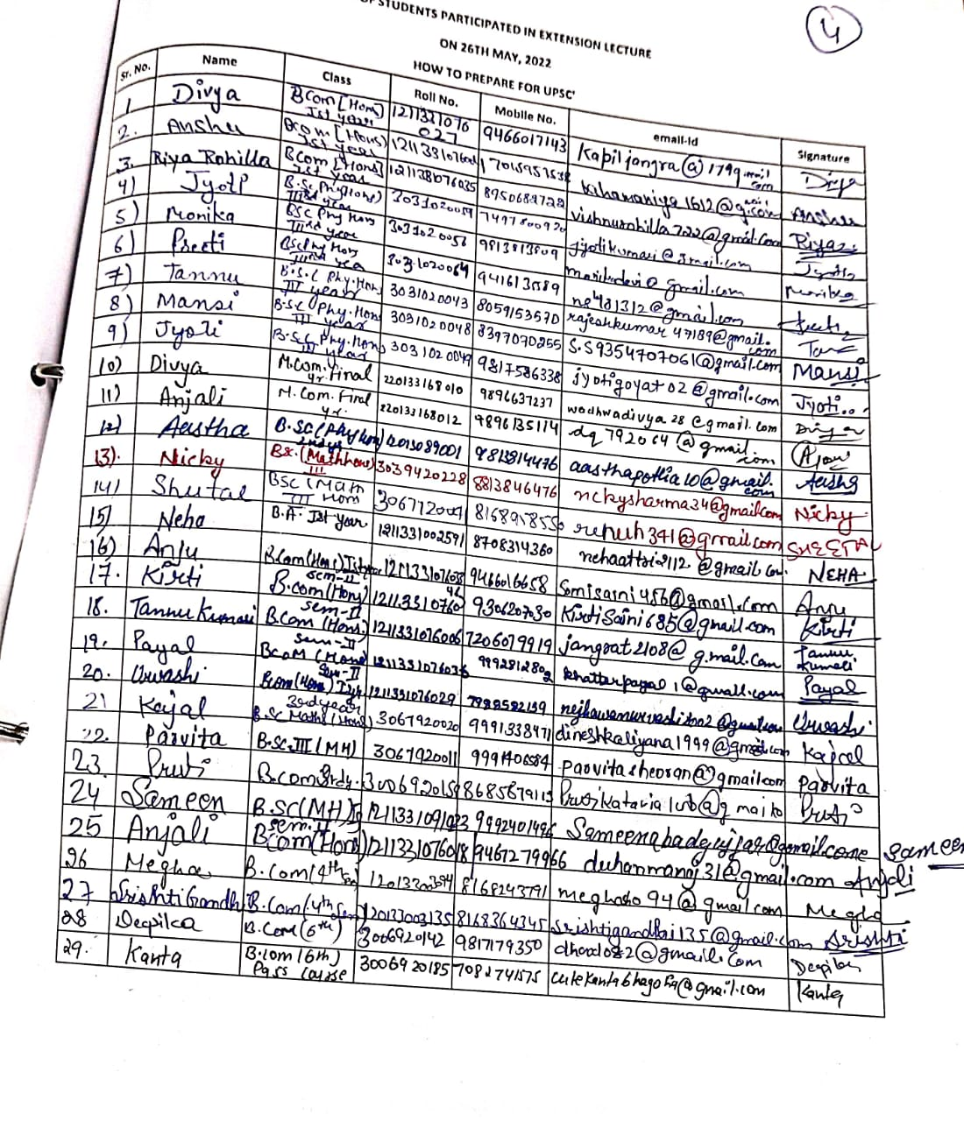

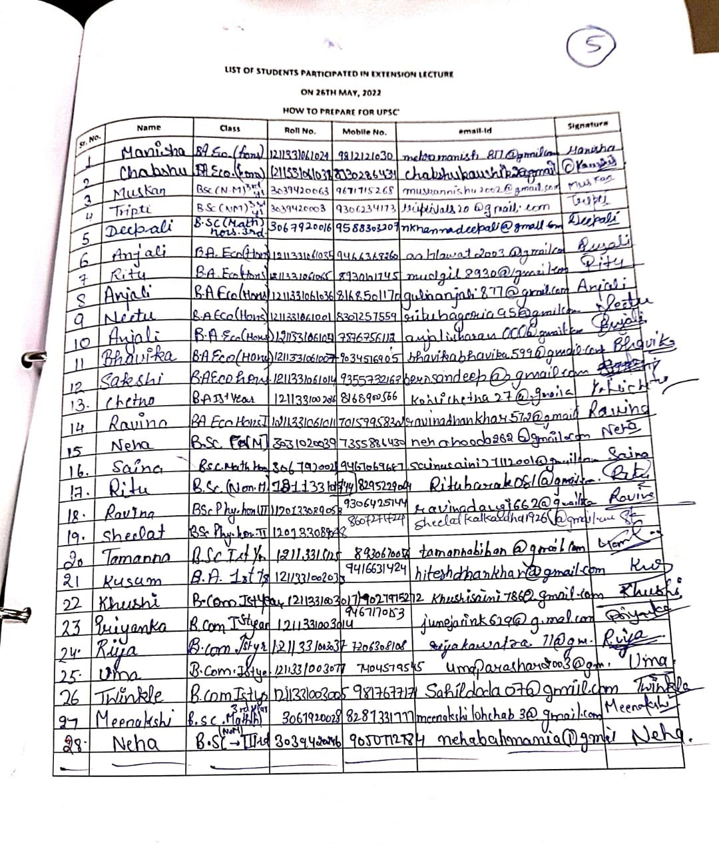

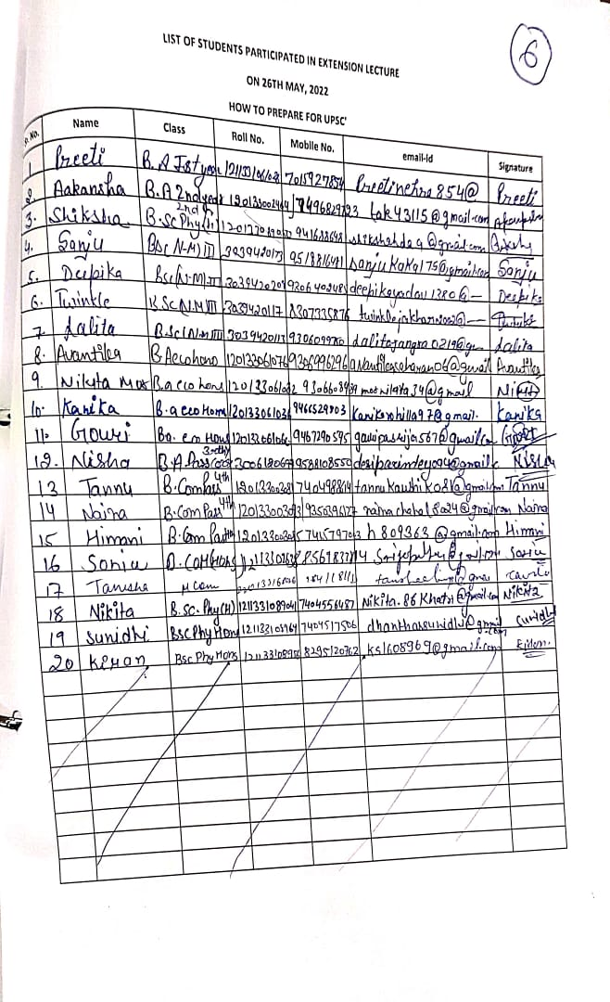

**Activity 7:**

Skill development Agreement is done with Saylor Academy on 26 June 2022 for three years on not for profit basis.

