**Library Details:**

* 67935 books
* 2 print journal (Economic political weekly and Current science )
* 19 news papers ( 35 copies)
* 34 magazines ( 45 copies)
* National digital library of India
* British council
* Shodh hindu
* Mlib
* SOUL Software

**AUTOMATED LIBRARY SYSTEMS HAVING ACCESS TO E-RESOURCES**

The record of books in the library is maintained through SOUL software. It is used to maintain a catalogue of books. The library also provides access to free Journals, books and other reading material through https://www.britishcouncil.in/ (N-list, British council of India, national digital library of India).

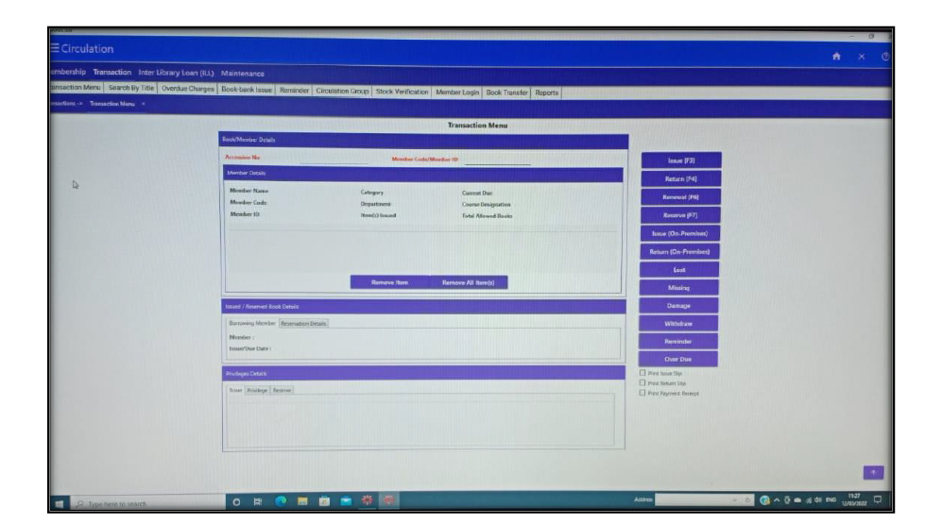

**Catalogue of Books**

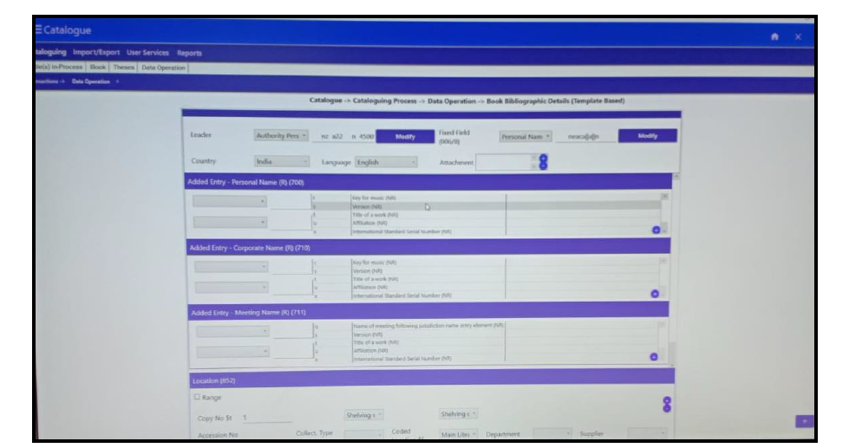

**Book Search using OPAC**

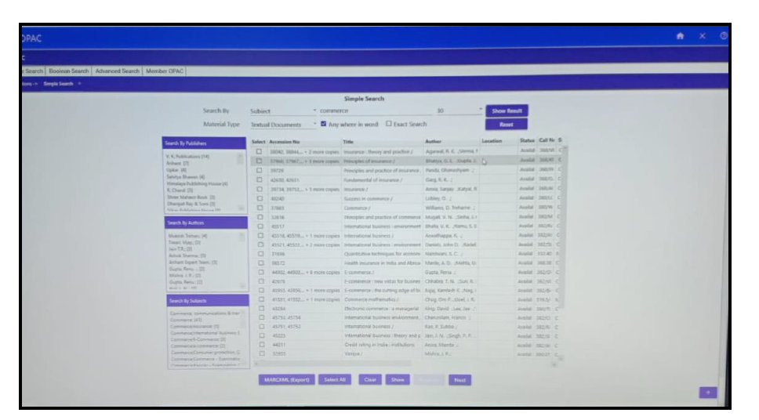

**SOUL Software**

