Parent-Teacher Meeting
31 Oct, 2025
Government Post Graduate Women’s College, Rohtak A Parent-Teacher Meeting was organized under the Mentor-Mentee Committee at Government Post Graduate Women’s College, Rohtak.

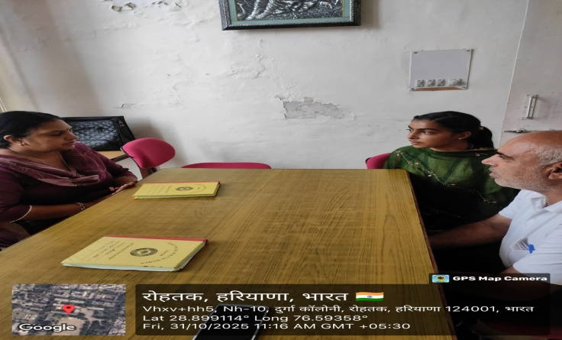
The meeting aimed to provide a platform for teachers and parents to discuss students’ academic progress, behavior, and overall development. Around 200 parents from all three faculties participated enthusiastically in the meeting and actively contributed to their wards’ growth. The Principal, Dr. Shamsher Singh, welcomed the parents and expressed his gratitude for their cooperation. He stated that such meetings help improve students’ attendance, academic performance, and discipline. The participation of parents in college activities has increased, which is helping enhance the overall quality of education. The program was successfully coordinated with the special efforts of Dr. Jyoti (IQAC In-charge), Dr. Pravesh, Dr. Sonika, Dr. Harsh, Dr. Dileep, Dr. Tamanna, Dr. Monika, Dr. Rohini Sharma, and Dr. Pooja (NSS). The entire teaching and non-teaching staff of the college was present on the occasion.
