OFFICE OF THE PRINCIPAL, GOVT PG COLLEGE FOR WOMEN, ROHTAK
ACTION TAKEN REPORT OF ANTI TOBACOO SQUAD (28 October 2025)

GOVERNMENT COLLEGE FOR WOMEN, ROHTAK ACTION TAKEN REPORT In compliance with letter no. KW DHE-010001/2/2021-Coord.(1) dated Panchkula, 25.06.2025, a Street Play on Anti-Tobacco Awareness was organized in the premises of Government College for Women, Rohtak, under the aegis of the Anti-Tobacco Squad on 28 October 2025. The objective of the event was to create awareness among students about the harmful effects of tobacco use and to promote a tobacco-free lifestyle. The students of the college presented a thought-provoking and impactful street play depicting the physical, social, and emotional consequences of tobacco consumption.The participants — Rakhi, Hanshika, Krishti, Navita, Mamta, Muskan, Arti, Kirti, Somwati, and Vidisha — delivered powerful performances that effectively conveyed the message. More than 500 students and faculty members attended and appreciated the presentation.The activity successfully fulfilled its aim of sensitizing the college community towards a healthy, tobacco-free environment.The Principal, Dr. Shamsher Hooda, appreciated the efforts of the Anti-Tobacco Squad and the participants for their commendable performance. He emphasized that such awareness activities play a vital role in shaping responsible and health-conscious citizens. He encouraged the students to take the message beyond the college campus and inspire others to adopt a tobacco-free lifestyle.Dr. Abhilasha Rohilla, Convener of the Anti-Tobacco Squad, praised the enthusiasm and dedication of the students for presenting a socially relevant and impactful performance. She highlighted that the street play effectively communicated the dangers of tobacco use and motivated students to lead by example in creating a tobacco-free environment. She also expressed gratitude to the Principal for his guidance and to all faculty members for their cooperation and support in making the event a success. Incharge, Anti-Tobacco Squad Dr. Abhilasha Rohilla (Associate Prof of English)

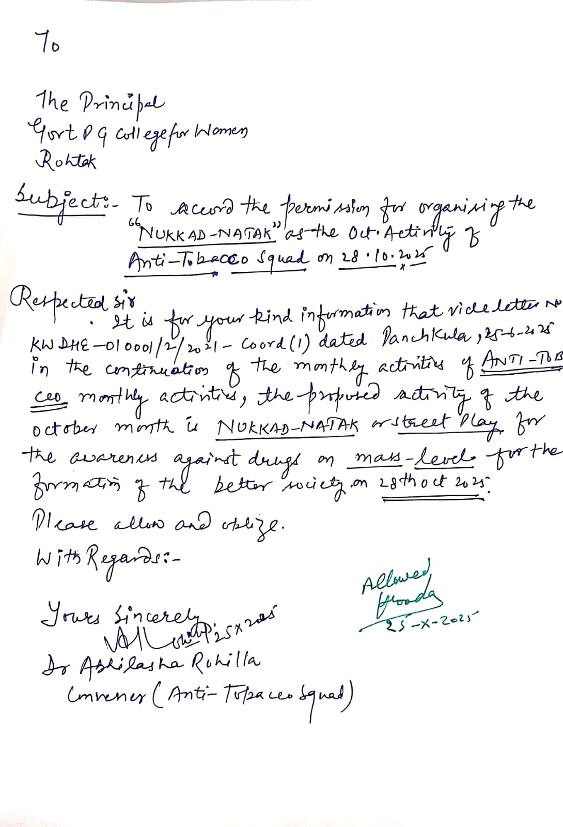

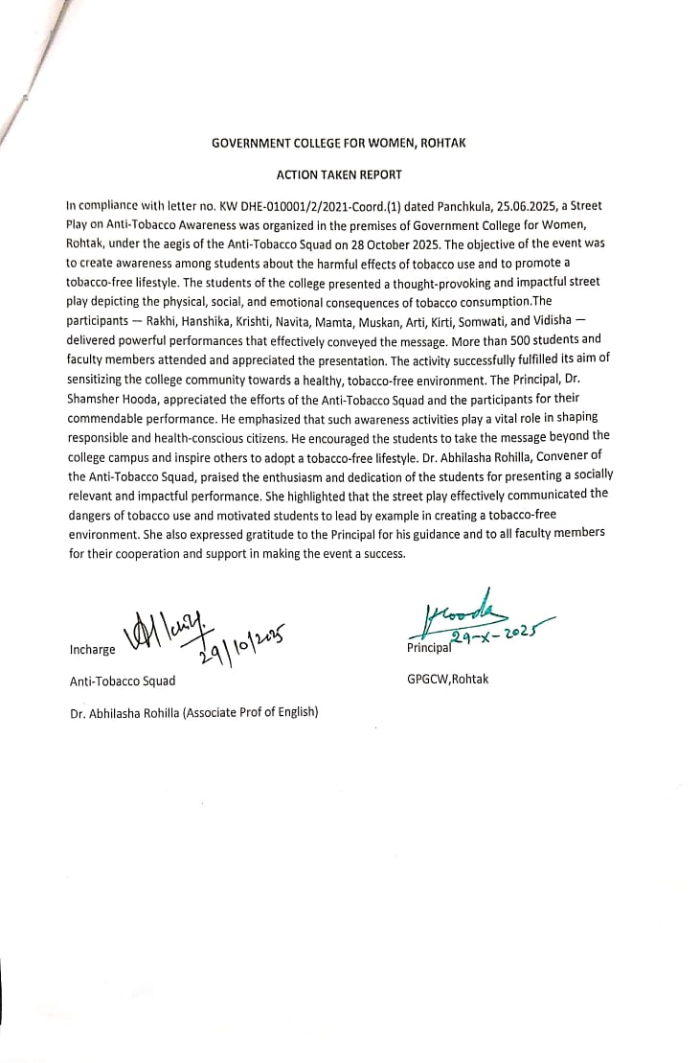

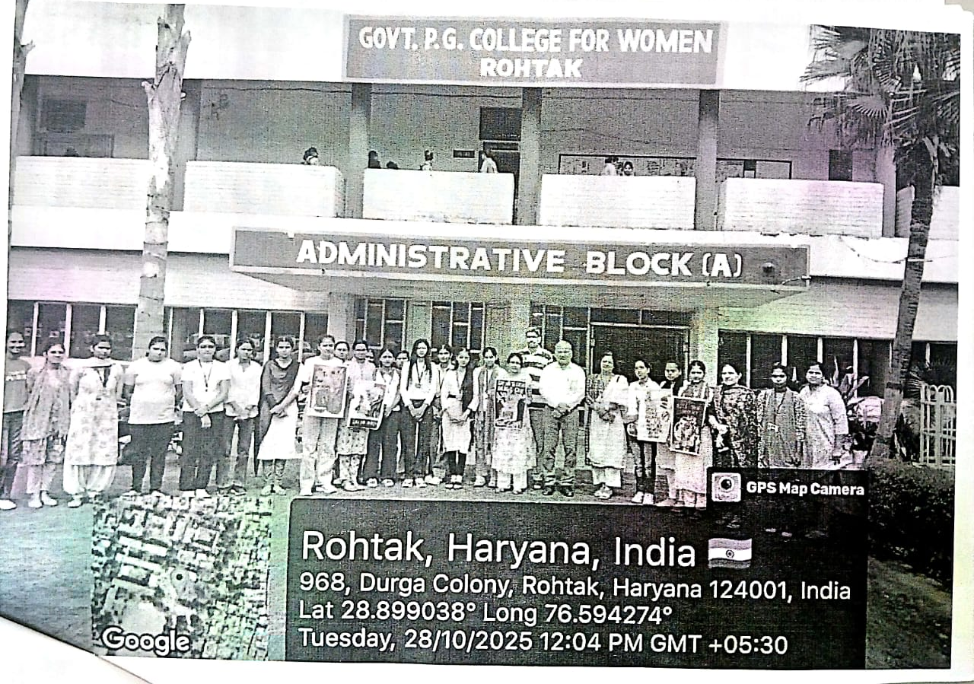
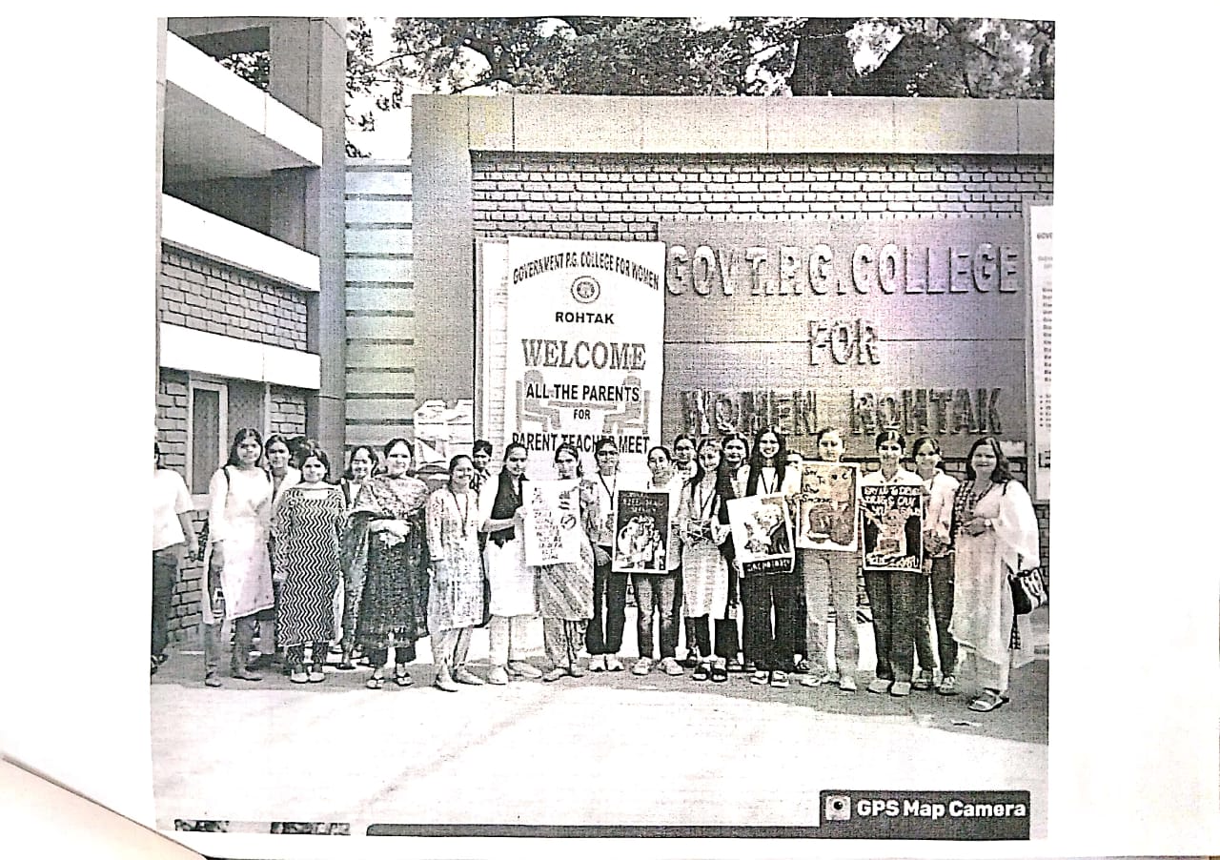
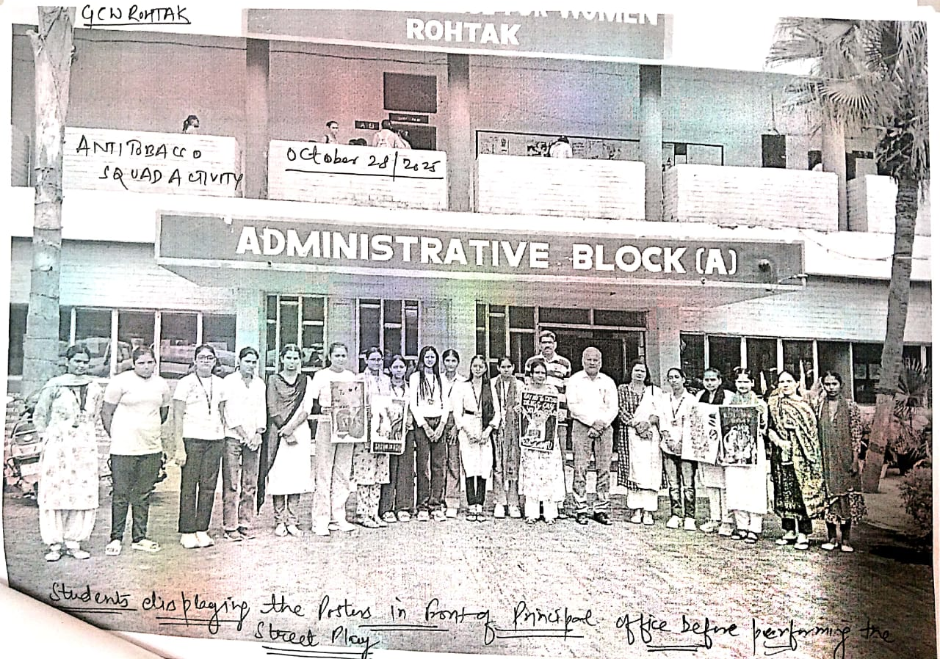
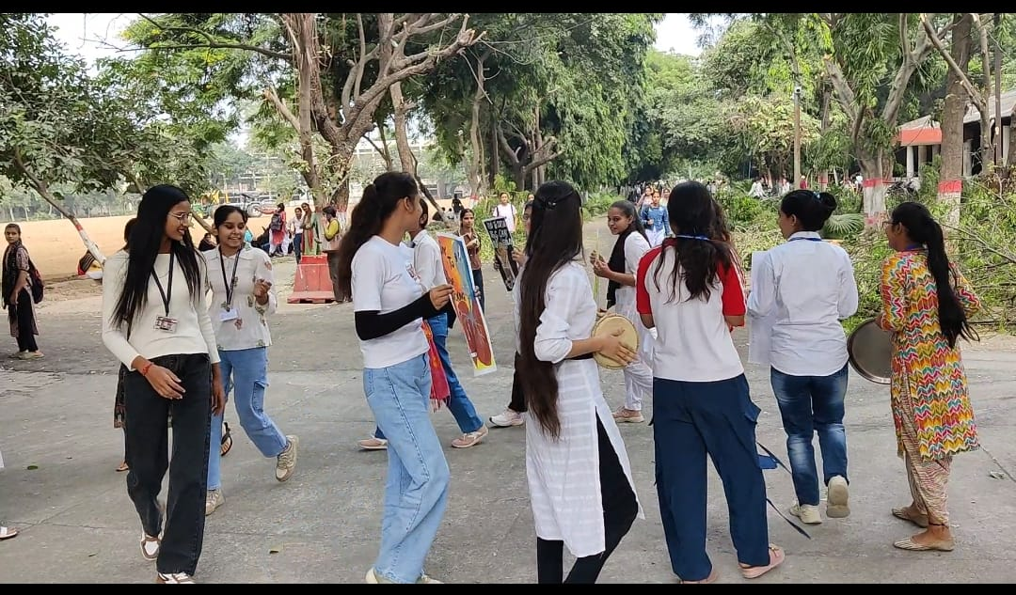
Students performing Nukkadnatak on Anti Tobacco
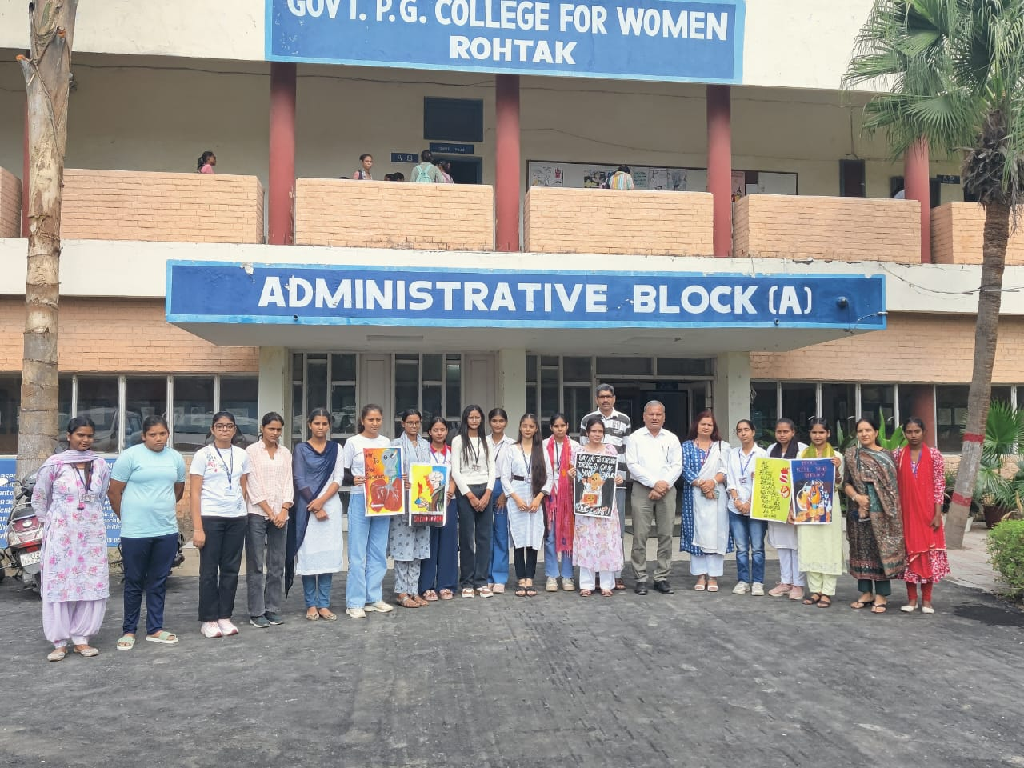
Students displaying their anti tobacco event posters in front of Principal Office
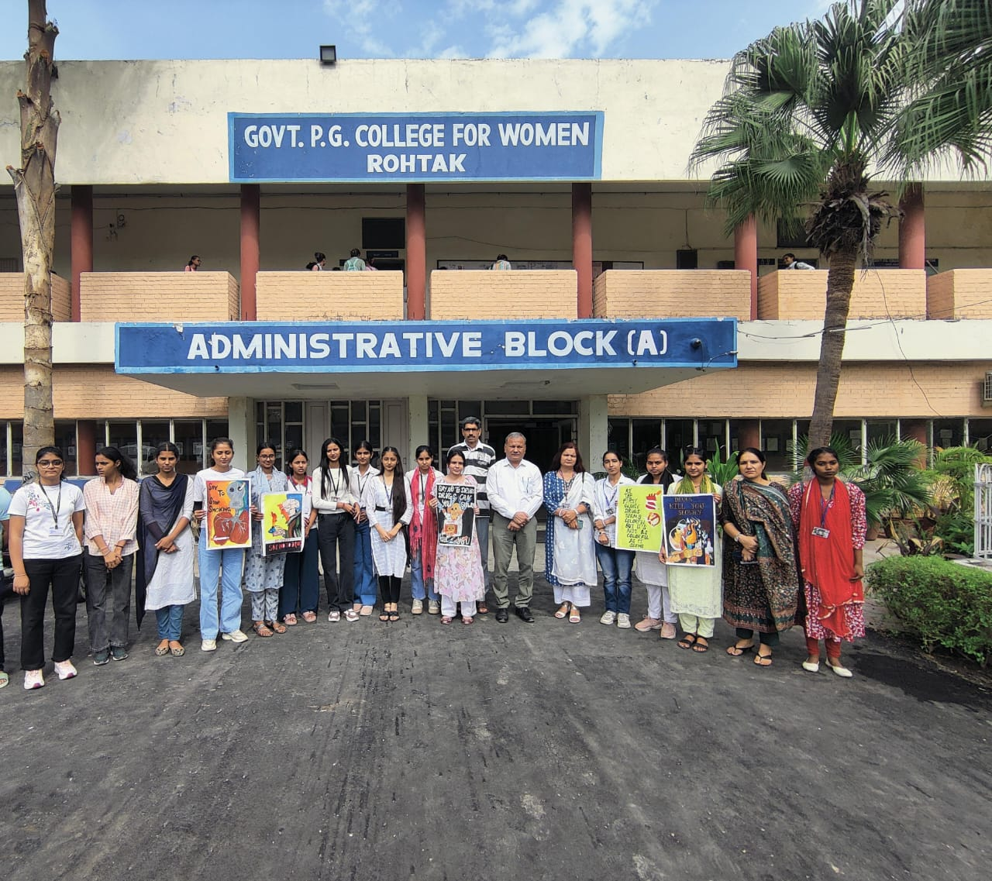

Students with respected Principal Sir
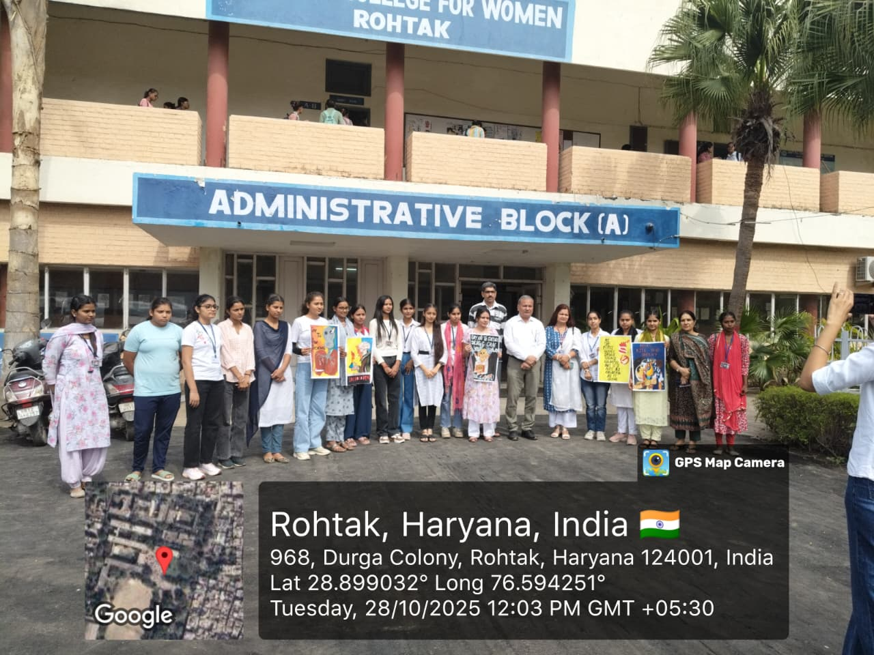
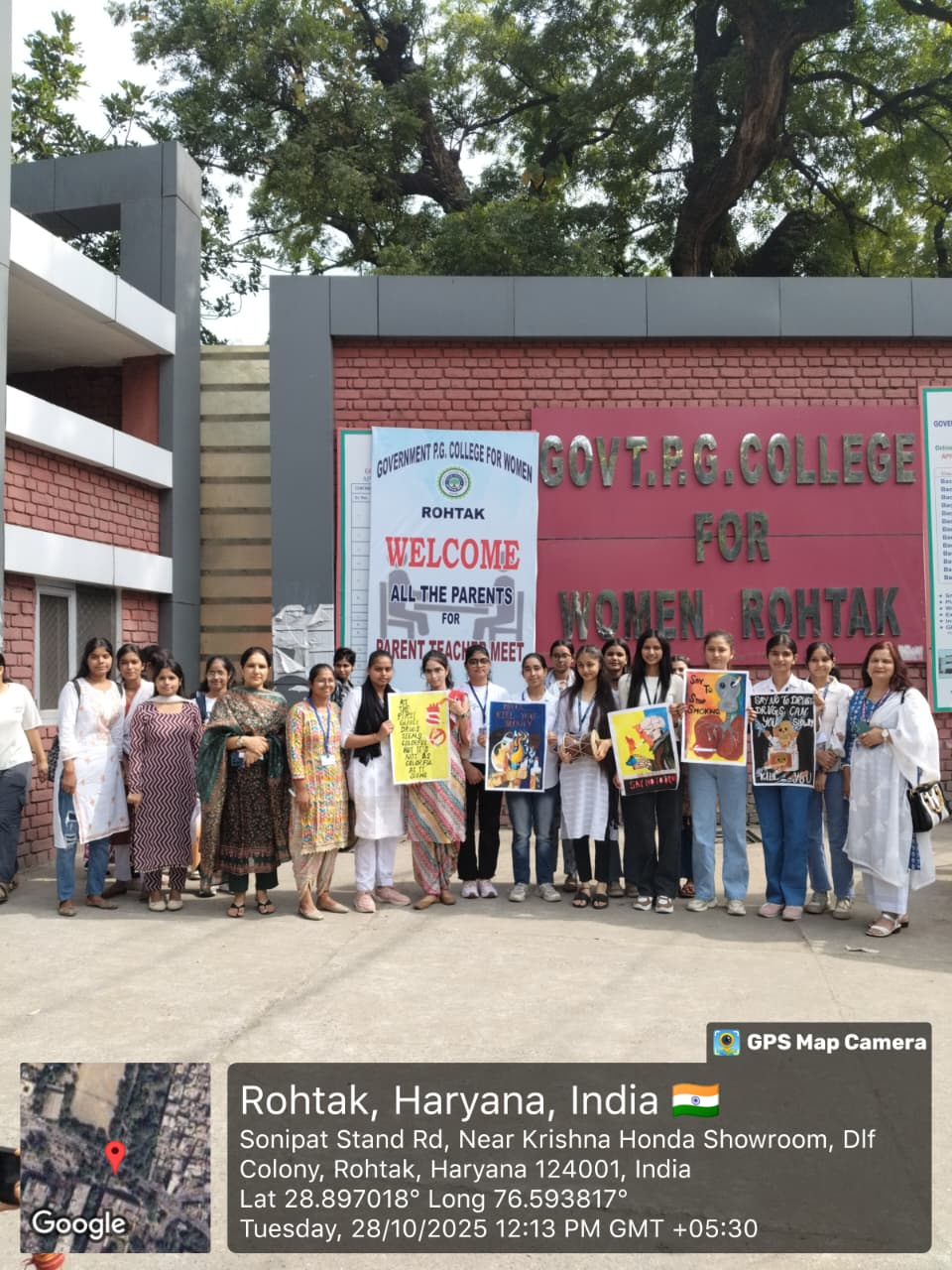

Post performance of street Play against Drug Abuse by students
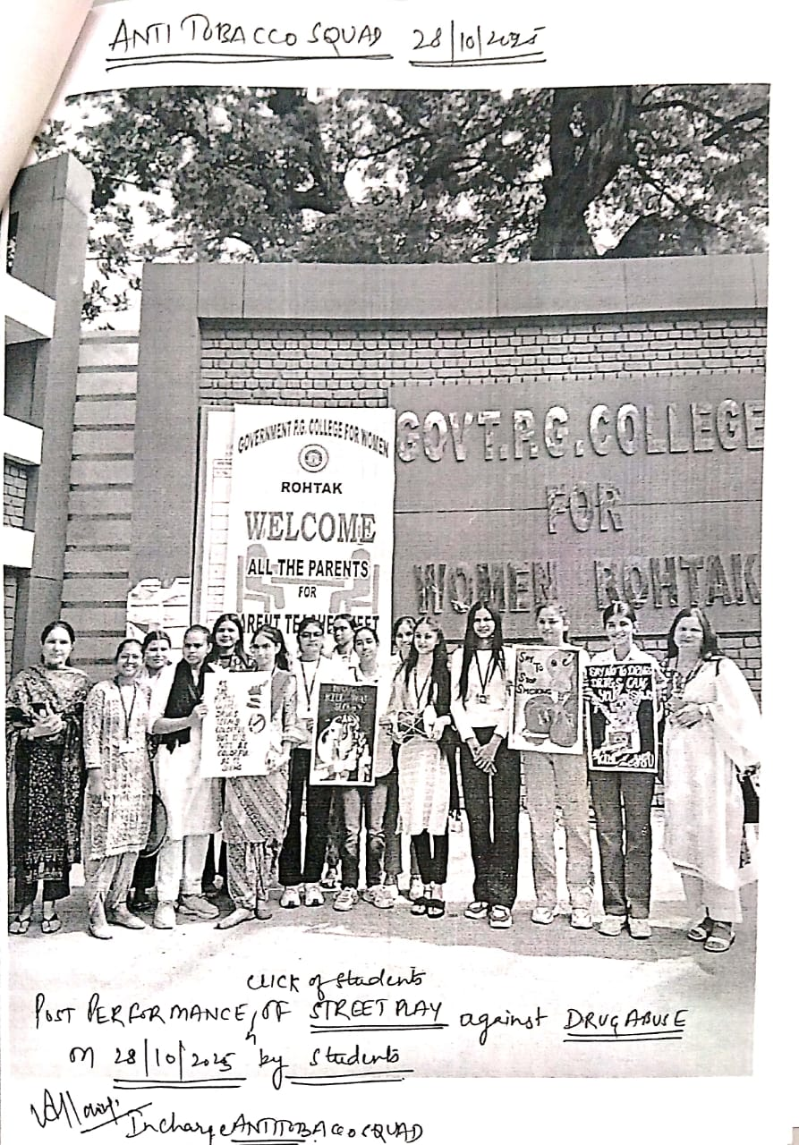

Attendance Charts:
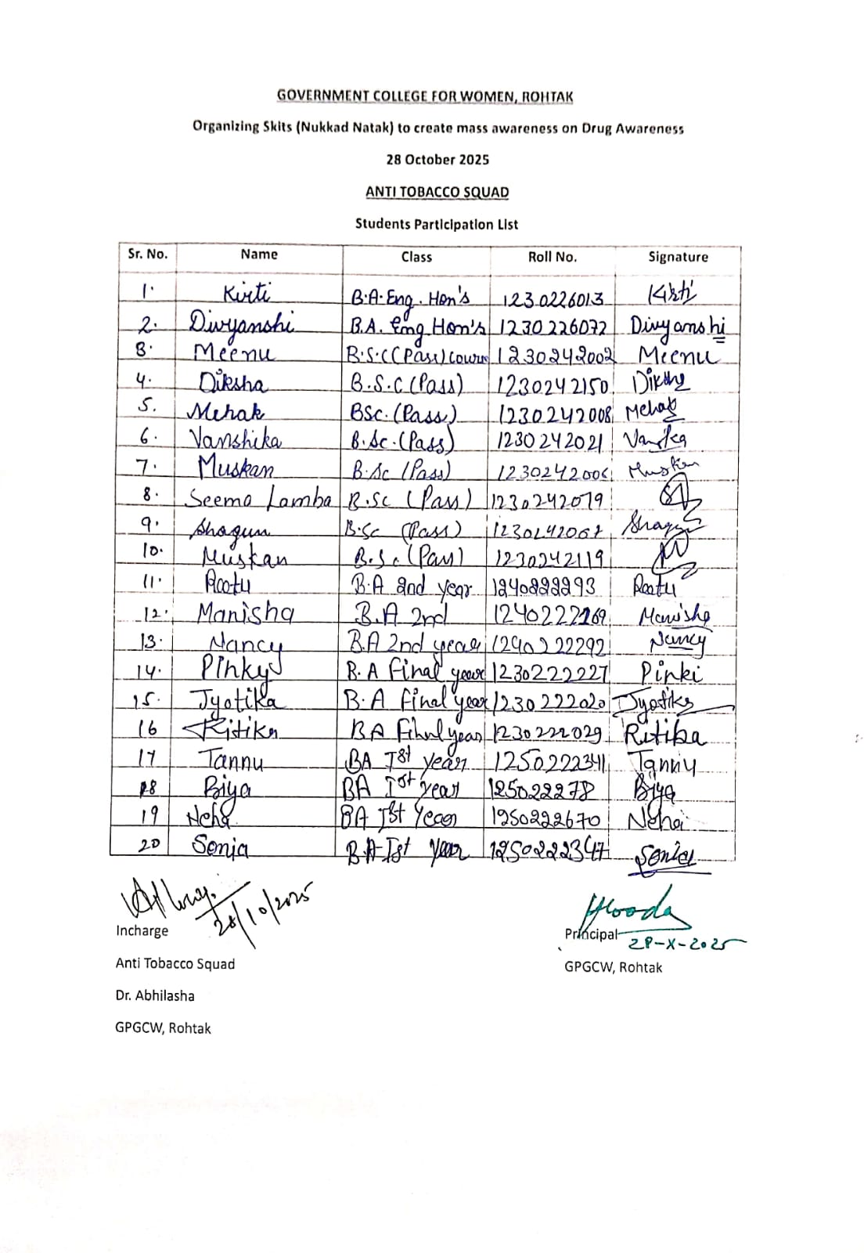

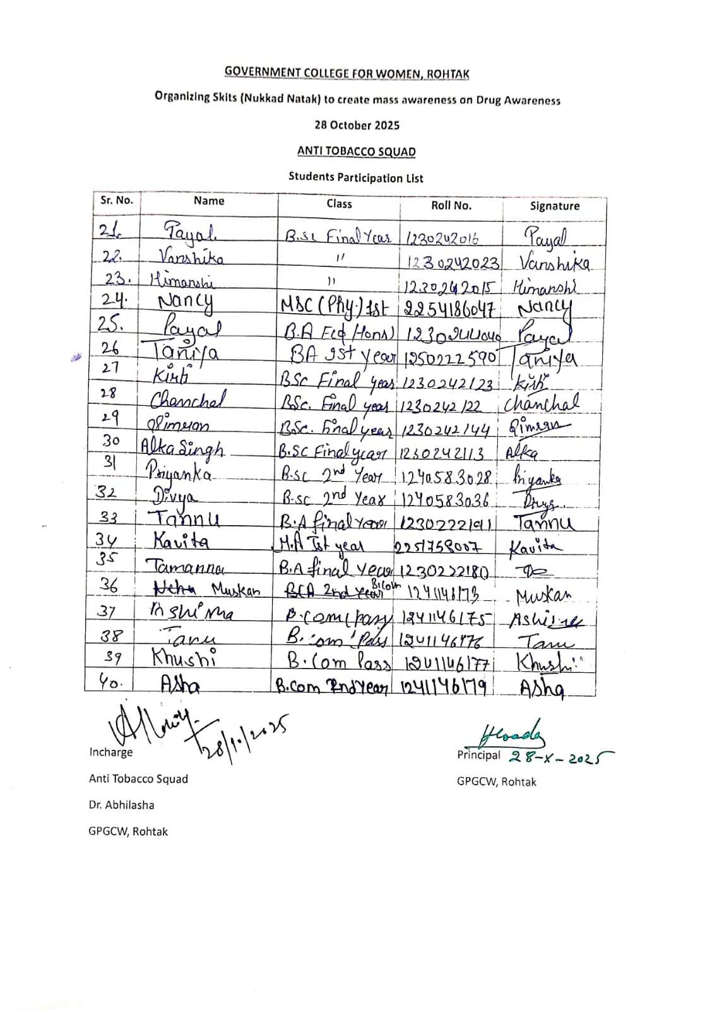

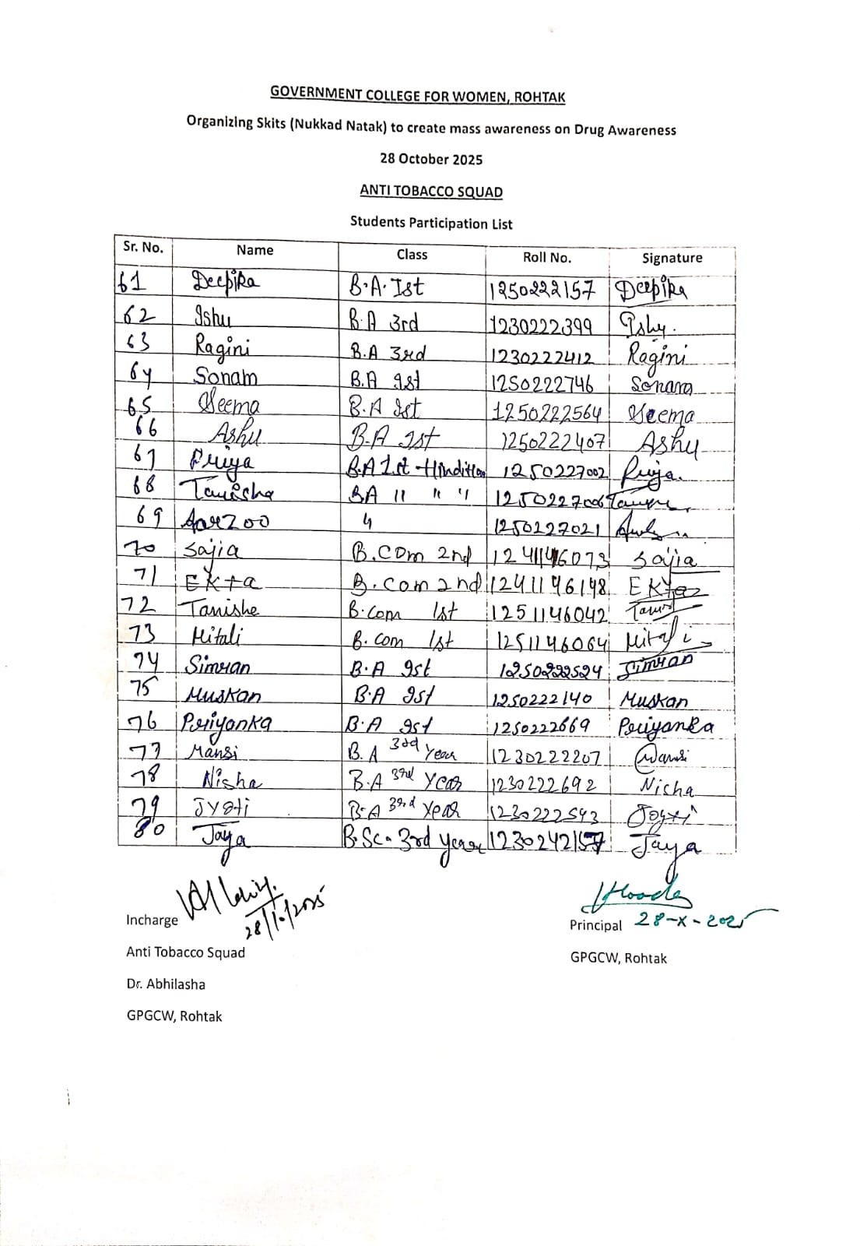
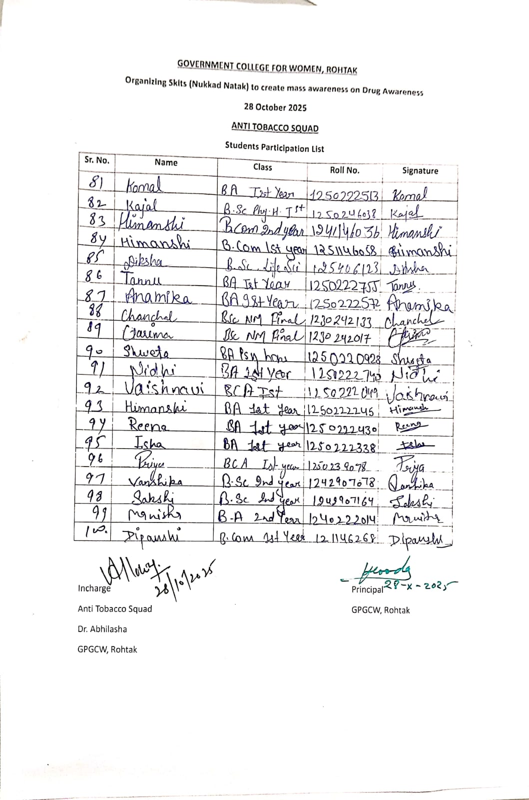

Press Reports: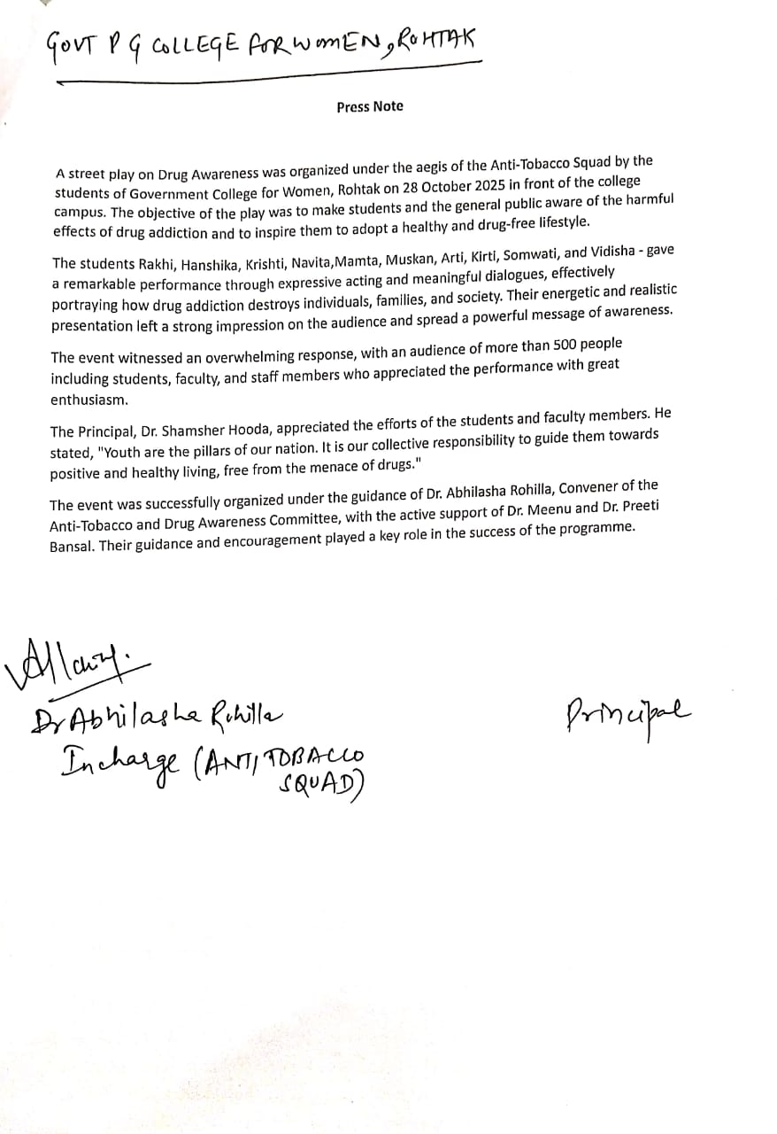

News Section:
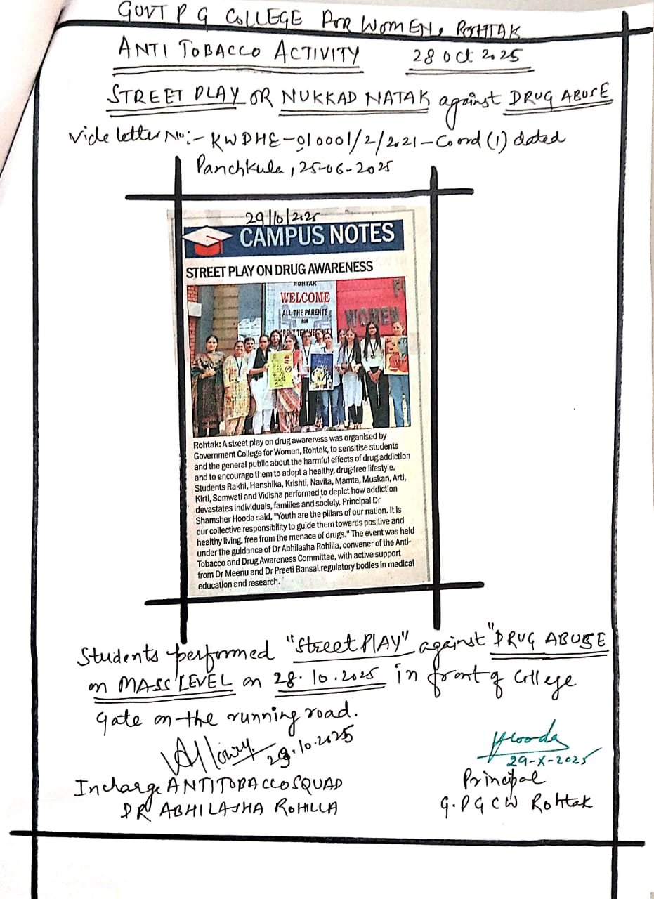
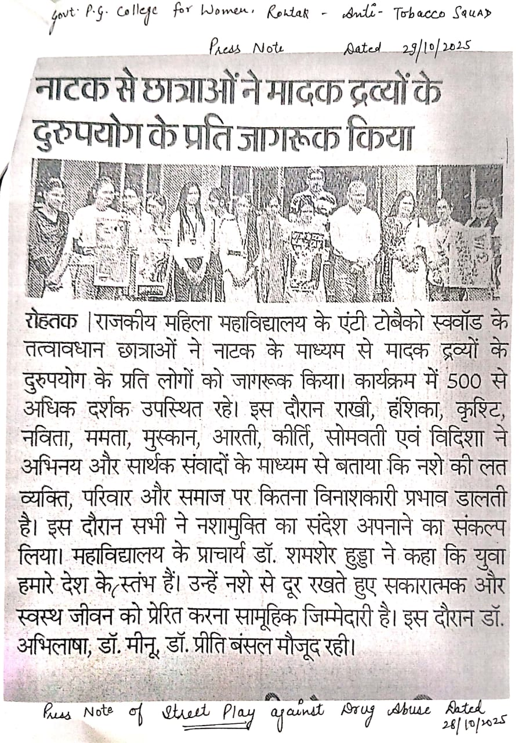
Press note of street play

