Self-Defense Workshop

A ten-days self-defense workshop was organized from 30 Oct to 12 nov 2025 by the Women's Cell at Government Post Graduate College for Women, Rohtak.
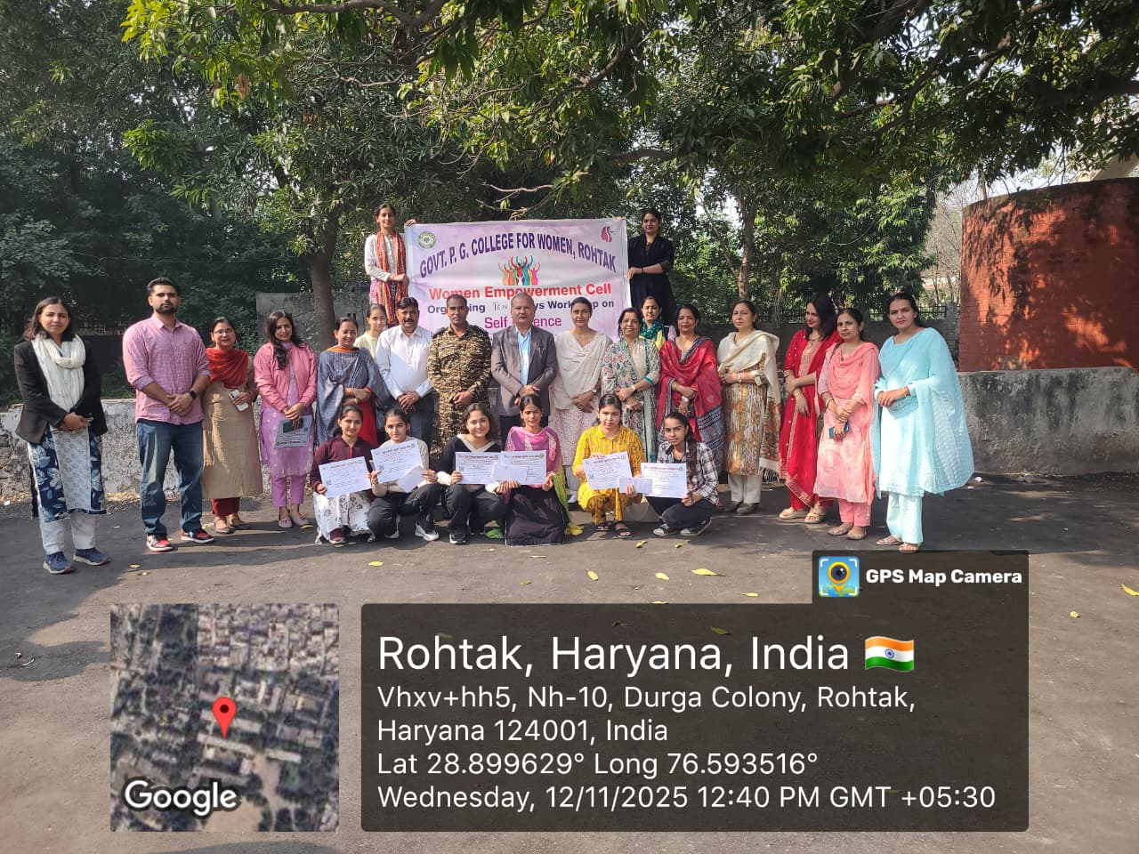

The college principal, Dr. Shamsher Singh, distributed certificates to the trained students at the closing ceremony today.
Approximately 100 students received training in this program. Self-defense instructor Shri Rohtash Kumar trained the students for ten days. Shri Rohtash is an international self-defense instructor. The principal motivated the students to imbibe the skills taught during the training throughout their lives.
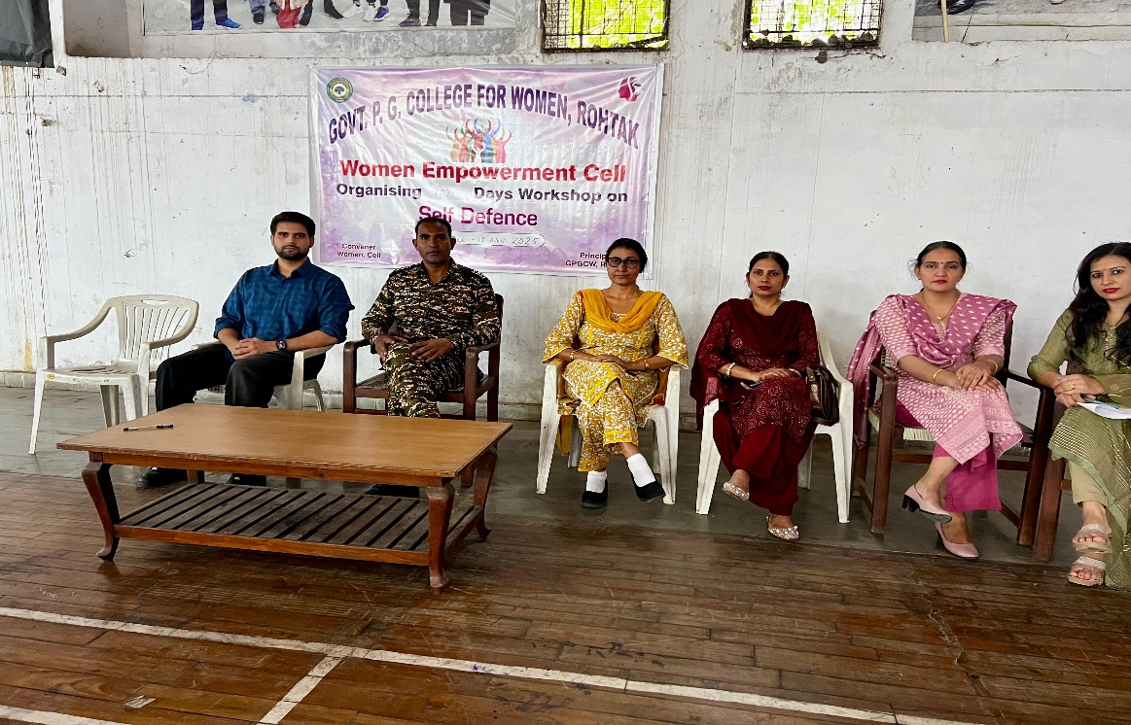

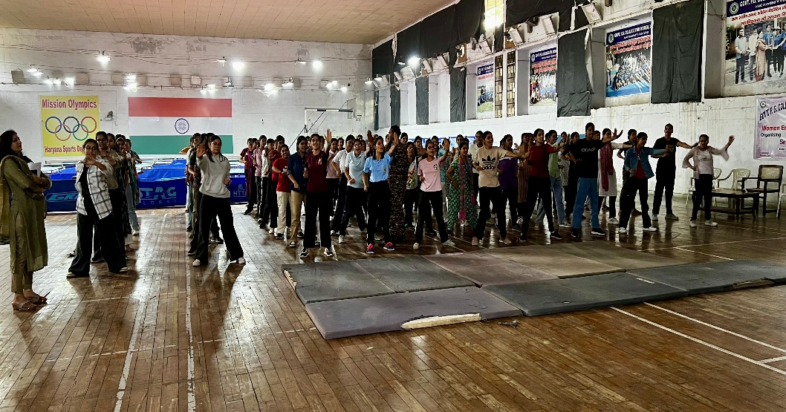
In his address, the principal told the students that every student needs this type of training in today's times. Dr. Deepak Malik, Dr. Nisha Malik, Dr. Jyoti, Dr. Neeraj Kadian, Dr. Renu, Dr. Basant, Dr. Vinod, Dr. Manju, Dr. Monika, Dr. Suman, Dr. Pooja, Dr. Neha, and others were present on this occasion.

