Placement Cell Activity November 2025
On 14 November 2025, the two-day workshop was conducted by the Placement Cell at Government Post Graduate Women’s College, Rohtak, successfully. Two sessions were organized today, focusing on interview skills and mock interviews.
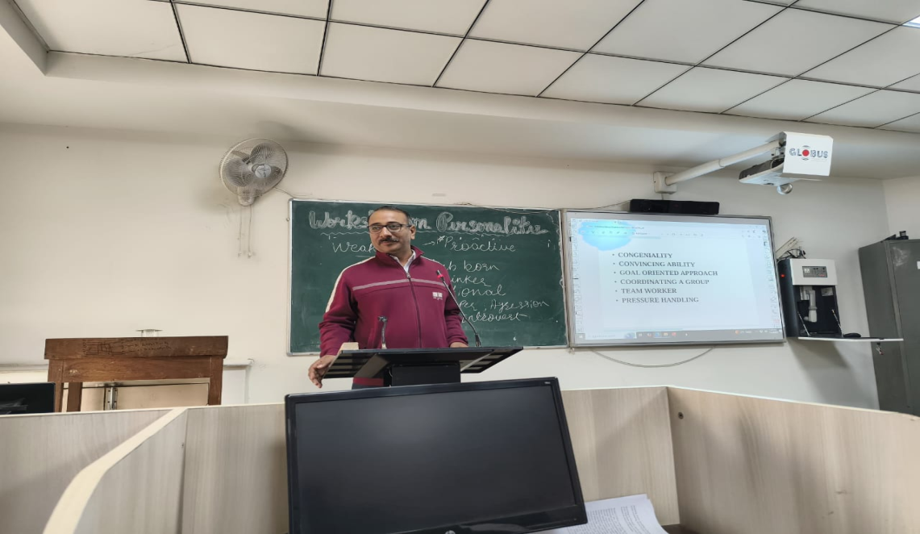

In the third session, Ms. Suchitra explained in detail the various activities involved in interview skills. She emphasized that students should identify their abilities and use their strengths and challenges effectively during interviews.
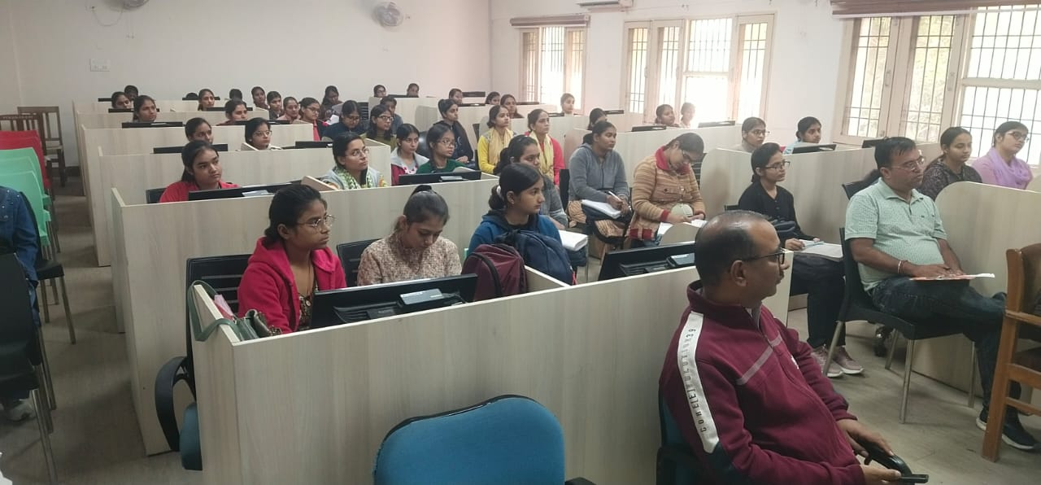

She also advised that students must include important points in their résumé that set them apart from others, but they should never add anything that does not genuinely belong to them.
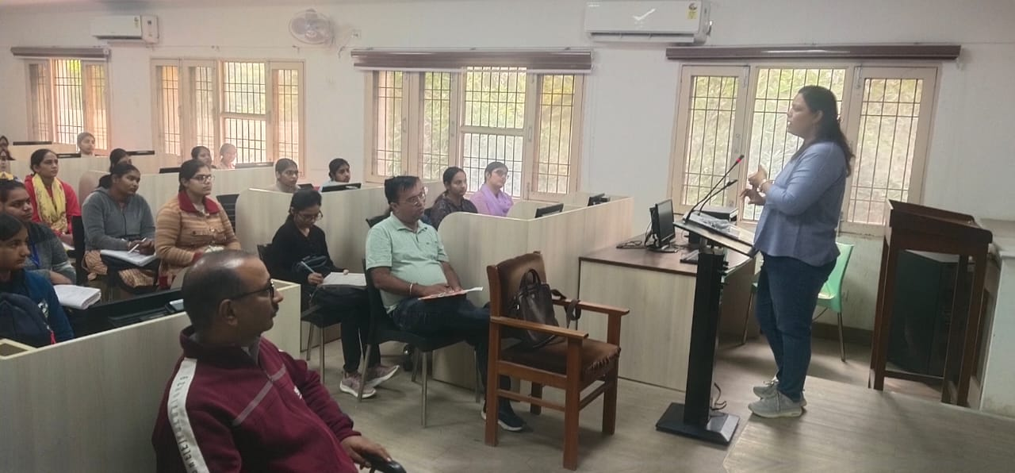
In the final session, a mock interview was conducted for the students, in which they performed remarkably well. After this session, the Placement Cell expressed gratitude to both experts, Mr. Dinesh Madan and Ms. Suchitra, and mentioned that similar events will be organized in the future as well.

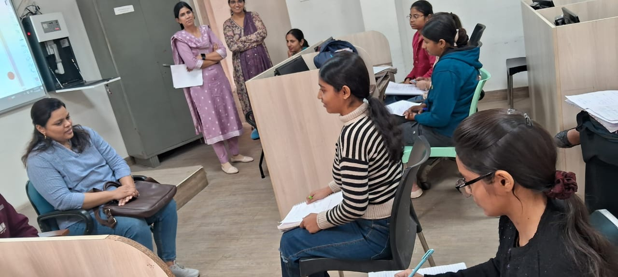
The Principal of the college, Dr. Shamsher Singh, extended a vote of thanks to both experts.

