NCC day 23 November 2025
The Government Postgraduate College for Women, Rohtak (GPGCW Rohtak) celebrated NCC Day with great enthusiasm on 23 Nov 2025.
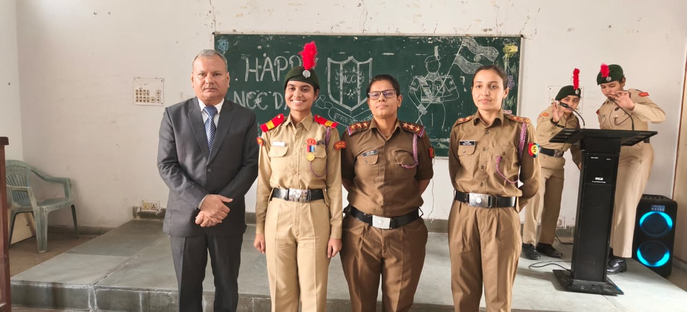

Senior Girls cadet instructors Saroj Malik and Garima were present as chief guests. As part of the program, article writing competitions, patriotic and cultural presentations were organized for the cadets, in which 85 NCC cadets participated enthusiastically.
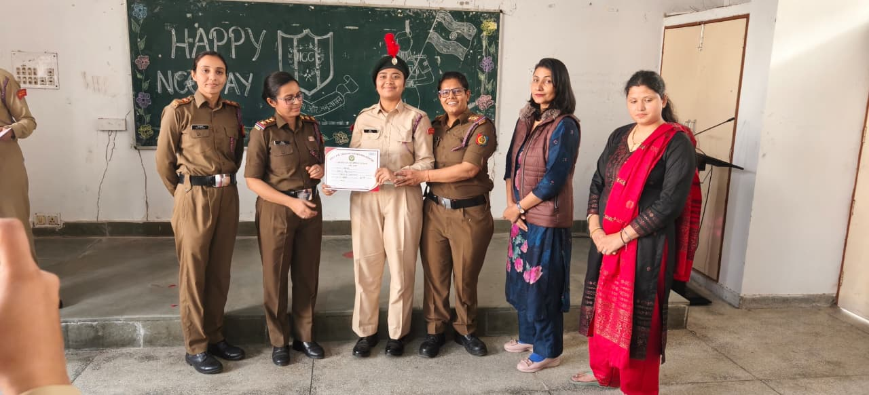

The chief guests praised the cadets' discipline, dedication, and spirit of national service and encouraged them to excel in life.

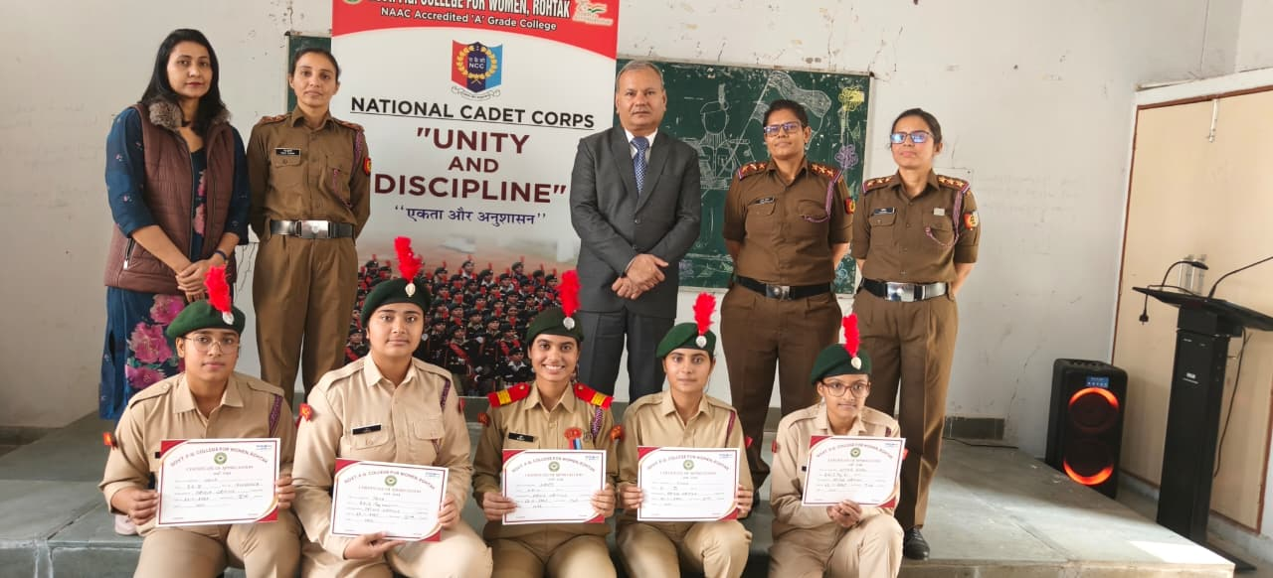
Finally, Principal Dr. Shamsher Hooda honored the winning participants and wished them a bright future. The program was successfully conducted by the NCC unit. Lieutenant Renu and Dr. Neeraj were present on the occasion.

